caAERS v 1.0
End User Guide

Document Change History
Version Number | Date | Contributor | Description
V0.05 | June 12, 2007 | Jason Carmichael | Initial Template
V0.1 | July 29, 2007 | Jason Carmichael | Initial Draft based on Iteration v. 4
V0.2 | August 10, 2007 | Paul Galvin | Completed draft of Chapter 2 halfway through expedited report.
V0.3 | August 16 | Paul Galvin | New format of the user guide based on tasks rather than modules.
V0.4 | August 24 | Paul Galvin | Redone with grammar and wording corrections.
V0.5 | September 19 | Paul Galvin | Incorporated feedback from BAH and WFU. Need to continue updating because of new flows
V0.6 | 11/13/2007 | Paul Galvin | New format: added quick reference points for each section of the application.
V0.7 | 01/03/08 | Jennifer Reed | Removed quick reference, added step-by-step instructions.
V0.8 | 01/07/08 | Jennifer Reed | Added coverage of new functionality and fixes from Iteration 7, 8, and 9.
V0.9 | 02/09/08 | Jennifer Reed | Updated to represented changes from last release
V1.0 | 02/12/08 | Jennifer Reed | Minor updates
V1.1 | 02/27/08 | Jennifer Reed | Updates to AE section


Updated February 27, 2008
Copyright and License page
Copyright 2007 SemanticBits, LLC. This software was developed in conjunction with the National Cancer Institute, and so to the extent government employees are co-authors, any rights in such works shall be subject to Title 17 of the United States Code, section 105.
Redistribution and use in source and binary forms, with or without modification, are permitted provided that the following conditions are met:
1. Redistributions of source code must retain the above copyright notice, this list of conditions and the disclaimer of Article 3, below. Redistributions in binary form must reproduce the above copyright notice, this list of conditions and the following disclaimer in the documentation and/or other materials provided with the distribution.
2. The MedDRA terminology was developed by the International Conference on Harmonisation (ICH) and is owned by the International Federation of Pharmaceutical Manufacturers and Associations (IFPMA) acting as trustee for the ICH steering committee. The MedDRA codeset is not included with the caAERS source code. For information about obtaining and using MedDRA, go to http://www.meddramsso.com.
3. The end-user documentation included with the redistribution, if any, must include the following acknowledgment:
"This product includes software developed by SemanticBits, LLC and the National Cancer Institute (NCI).”
If no such end-user documentation is to be included, this acknowledgment shall appear in the software itself, wherever such third-party acknowledgments normally appear.
4. The names "The National Cancer Institute", "NCI" and “SemanticBits, LLC” must not be used to endorse or promote products derived from this software.
5. This license does not authorize the incorporation of this software into any proprietary programs. This license does not authorize the recipient to use any trademarks owned by either NCI or SemanticBits, LLC.
6. THIS SOFTWARE IS PROVIDED "AS IS," AND ANY EXPRESSED OR IMPLIED WARRANTIES, (INCLUDING, BUT NOT LIMITED TO, THE IMPLIED WARRANTIES OF MERCHANTABILITY AND FITNESS FOR A PARTICULAR PURPOSE) ARE DISCLAIMED. IN NO EVENT SHALL THE NATIONAL CANCER INSTITUTE, SAIC, OR THEIR AFFILIATES BE LIABLE FOR ANY DIRECT, INDIRECT, INCIDENTAL, SPECIAL, EXEMPLARY, OR CONSEQUENTIAL DAMAGES (INCLUDING, BUT NOT LIMITED TO, PROCUREMENT OF SUBSTITUTE GOODS OR SERVICES; LOSS OF USE, DATA, OR PROFITS; OR BUSINESS INTERRUPTION) HOWEVER CAUSED AND ON ANY THEORY OF LIABILITY, WHETHER IN CONTRACT, STRICT LIABILITY, OR TORT (INCLUDING NEGLIGENCE OR OTHERWISE) ARISING IN ANY WAY OUT OF THE USE OF THIS SOFTWARE, EVEN IF ADVISED OF THE POSSIBILITY OF SUCH DAMAGE.
A number of people have made contributions to the development of caAERS. The table below lists the primary developers, subject matter experts, testers, technical writers, and key contributors.
Development Team
Development | User’s Guide | Program Management
Vinay Kumar¹ | Jennifer Reed¹ | Edmond Mulaire¹
Joshua Philips¹ | Paul Galvin³ | Ram Chilukuri¹
Rhett Sutphin²
Krikor Krumlian³
Srini Akkala¹
Biju Joseph¹
Karthik Iyer¹
Jared Flatow²
Sean Whitaker²
CTIS (AdEERS Integration)
Key Contributors
Sharon Elcombe, MA⁴ | Ann Setser⁷ | Lisamarie Schick⁶
Robert Morrell⁵ | Anne Tompkins⁸ | Christo Andonyadis⁹
Sonja Hamilton⁴ |  | Warren Kibbe, Ph.D.²
Jennifer Frank⁴ |  | Cal Collins³
Kim Livengood⁵
Jean Hanson⁴
Jennifer Sorbo⁴
Steven Cheng⁵
Larry Esser⁴
Renee Webb, MA, CCRC²
David Patton²
¹SemanticBits ²Northwestern University ³Akaza Research ⁴Mayo Clinic ⁵Wake Forest University ⁶Booz Allen Hamilton ⁷CTEP ⁸DCP ⁹NCI CBIIT

Contacts and Support
Edmond Mulaire | edmond.mulaire@semanticbits.com
caAERS Project Site | http://gforge.nci.nih.gov/projects/caaersappdev/

LISTSERV Facilities Pertinent to software teams
LISTSERV | URL | Name
Caaers-Developers | Caaersappdev-developers@gforge.nci.nih.gov | caAERS Developers Listserv
Caaers-Domain | Caaersappdev-developers@gforge.nci.nih.gov | caAERS Domain Listserv
Caeers-Technical | caaersappdev-technical@gforge.nci.nih.gov | caAERS Technical Listserv

Table of Contents
Chapter 1 Introduction to the Guide 1
Overview of the Guide 1
Audience 1
Organization of this Guide 1
Relevant Documents 2
Document Text Conventions 2
Chapter 2 Overview of the Software 5
Software Overview 5
Components of the Software 5
System Requirements 6
User Name 6
Password 6
Resetting your password 6
Chapter 3 User Interface 7
User Interface 7
Launching the application 7
Exiting the application 7
Application Workspace 8
Navigation Elements 8
Expanding and Collapsing Windows 8
Additional Icons 9
Help 9
Instructions for the module/task 9
Instructions for a field 9
In-line 10
Online Help 10
Miscellaneous Interface features 10
Auto-complete functionality 10
Search functionality 10
Required fields/missing information 11
Chapter 4 User Roles 13
User Roles 13
Roles to Tasks 13
Chapter 5 Studies module 15
Creating a Study 15
Details 15
Therapies 16
Agents 16
Treatment Assignments 18
Disease 19
Sites 20
Investigators 21
Personnel 21
Identifiers 22
Overview 23
Searching for a Study 24
Editing a Study 25
Chapter 6 Subject module 26
Creating a Subject 26
Details 26
Choose Study 27
Review 28
Assign a Subject to a Study 28
Assignment by Selecting a Study 28
Searching for a Subject 30
Searching for a Subject 31
Editing a Subject 32
Chapter 7 Adverse Events module 33
Enter an Expedited Report 33
Begin 34
Enter AEs 34
Course and Agent 35
Reporter 37
Select Report 38
Describe Event 39
Patient Details 41
Pre-existing Conditions 42
Prior Therapies 43
Conmeds 44
Other Causes 44
Radiation 45
Surgery 46
Device 46
Labs 48
Attribution 49
Attachment 50
Submit 51
Submitter 52
Submit Report 53
Documenting Routine AEs 53
Begin 54
Categories 54
Adverse Events 55
Save 57
Managing Reports 58
Chapter 8 Advanced Search 61
Overview 61
Study Search 61
Subject Search 61
AE Search 62
Expedited Report Search 62
Routine AE Search 62
Chapter 9 Error Messages/Indicators and Problem Resolutions 65
Error Messages 65
Submission Errors 65
Activity Issues 66
System Errors 67
Support 67
Appendix A. References 69
Scientific Publications 69
caBIG Material 69
caGrid Material 69
caCORE Material 69
Appendix B. Glossary 71
Index 73

Introduction to the Guide
Topics in this chapter include:
- Overview of the Guide
- Audience
- Organization of this Guide
- Relevant Documents
- Document Text Conventions

Overview of the Guide
The caAERS User’s Guide covers the general use and operation of the caAERS application. Included here are step-by-step instructions for using caAERS to document and manage adverse events (AEs) and to prepare and submit expedited reports.
For detailed information about installing caAERS, refer to the caAERS Installation Guide. For detailed information about general administration tasks (including setting up users, rules, and reports), refer to the caAERS Administration Guide.

Audience
This manual is intended for end users (including CRAs, Adverse Event Coordinators, Study Coordinators, and Subject Coordinators) who will use caAERS to enter and manage adverse events and to prepare and submitted expedited adverse event reports.

Organization of this Guide
This guide includes general caAERS information, task-specific steps, and troubleshooting information. The following table briefly describes each chapter.
Chapter | Chapter Contents
Chapter 1 | Introduction to the Guide
Chapter 2 | Overview of the Software
Chapter 3 | User Interface
Chapter 4 | User Roles
Chapter 5 | Studies Module
Chapter 6 | Subjects Module
Chapter 7 | Adverse Events Module
Chapter 8 | Advanced Search
Chapter 9 | Error Messages/Indicators and Problem Resolutions
Appendix A | References
Appendix B | Glossary
Table 1-1 Chapter Outline of the End User Guide

Relevant Documents
This Guide focuses on topics of interest to end users. Additional information about caAERS can be found in the following documents:
Document | Location
caAERS_QuickStart _Guide | http://gforge.nci.nih.gov/frs/?group_id=249
caAERS Administration Guide | http://gforge.nci.nih.gov/frs/?group_id=249
caAERS Installation Guide | http://gforge.nci.nih.gov/frs/?group_id=249
Online help | Accessed by clicking , found in the upper-right hand corner of most windows
CTEP List of Organizations and Identifiers | http://ctep.cancer.gov/forms/Organization_Codes.txt
CTEP Therapy Classification | http://ctep.cancer.gov/guidelines/values.html
Table 1-2 List of relevant documents

Document Text Conventions
The following table shows various typefaces to differentiate between regular text and menu commands, keyboard keys, and text that you type. This illustrates how conventions are represented in this guide.
Convention | Description | Example
Bold & Capitalized Command  Capitalized command > Capitalized command | Indicates a Menu command  Indicates Sequential Menu commands | Admin > Refresh
text in small caps + text in small caps | Keyboard keys that you press simultaneously | Press shift + ctrl and then release both.
Boldface type | Options that you select in dialog boxes or drop-down menus. Buttons or icons that you click. | In the Open dialog box, select the file and click the Open button.
Italics | Used to reference other documents, sections, figures, and tables. | caCORE Software Development Kit 1.0 Programmer’s Guide
Italic boldface type | Text that you type | In the New Subset text box, enter Proprietary Proteins.
Note: | Highlights a concept of particular interest | Note: This concept is used throughout the installation manual.
Warning! | Highlights information of which you should be particularly aware. | Warning! Deleting an object will permanently delete it from the database.
{} | Curly brackets are used for replaceable items. | Replace {root directory} with its proper value such as c:\cabio
Table 1-3 Document Conventions

Overview of the Software
This chapter provides an overview of the software. Topics in this chapter include:
- Software Overview
- Component of the software
- System Requirements
- User name
- Password

Software Overview
The caAERS (Cancer Adverse Event Reporting System) application is an open source, standards-compliant application designed to collect, assess, and manage adverse events in cancer clinical trials. It is web-based, uses a controlled vocabulary, and enables multiple users to access, search for, and report on Adverse Events (AE), both in-house and to external agencies.
caAERS was developed to integrate with other caBIG-compliant CTMS components. This allows sharing of information across application. In addition, caAERS also has the ability to accept information from other systems by importing XML files containing the information.
caAERS is a caBIG silver-level compliant module (caBIG Compatibility Guidelines, Appendix A) and is interoperable with other caBIG-compliant Clinical Trial Management System (CTMS) components.

Components of the Software
The caAERS application has six modules:
- Adverse Events
- Studies
- Subjects
- Rules
- Administration
- Advanced Search
Each of the modules is used to collect or provide specific information. Used together, the modules track, maintain, and report any adverse events that occur during a clinical study at any of the participating organizations. For information on the caAERS Administration and Rules modules, see the caAERS Admin Guide.

System Requirements
caAERS is a web-based application. To access and use caAERS, your computer must meet the following requirements:
- Internet connection: speed of 56K or faster (broadband) recommended
- Browser: Firefox 1.5 or 2.0, Internet Explorer 7.0 or higher supported
- Display: resolution of 1024 x 768 or better is recommended, 800 x 600 is supported

User Name
The system administrator will create your account and assign you the user roles. Once the account is created in the system, you will have a user name and password.
Your user name will always be your email address. This field is case sensitive.

Password
When your account is created, you will be sent an email with a link to create your password. Click on the link to create a password. There is a password policy created during caAERS setup, so you may be limited on what you can use for a new password. If the password you enter doesn’t work, you will receive a message stating the password requirements that aren’t met.

Resetting your password
If at any time you need to reset your password, you are able to do so from the login screen. To reset your password:
- Click Forgot Password? on the login screen
- Enter {your Username (email address)} and click Reset Password
- caAERS will send you an email. Open the email and click on the link
Note: Your browser must be set up to allow new windows to open
- Enter {your user name}
- Enter {your password}
- Re-Enter {your password}
- Click Change Password
If your password doesn’t meet the security requirements for passwords, you will be given an error message stating the problem. If the password does match, you’ll receive a message with a link to the login page.

User Interface
This chapter provides an overview of the user interface. Topics in this chapter include:
- User Interface
- Description of the Interface
- Launching the application
- Exiting the application
- Application Workspace
- Help
- Miscellaneous Interface features

User Interface
caAERs is a web-based application, connected to a database. It was developed to work on all standard operating systems. Security measures include required user accounts and passwords, all controlled within the system.
To access caAERS, it must be installed on a local network. An end user connected to the network can launch their browser to access it.
Warning! The browser navigation elements (such as the Back or Forward buttons) should not be used. Using them may cause problems with the system and could cause you to lose information if you are in the middle of entering a study or AE. The application contains all necessary navigation elements.

Launching the application
To launch caAERS, open a web browser and enter the caAERS web address (provided by your system administrator). From here, you’ll be asked for your username and password to log in.
If you sign in with the wrong username or password, you will receive the message, “Incorrect username and/or password. Please try again.” After entering invalid information a certain number of times, you will be locked out of the system for a certain period of time. The number of times and duration of lockout are features set up by your caAERS administrator during configuration. For assistance with your user name and password, contact your administrator.

Exiting the application
To exit or logout of the caAERS application, click the Log out link located in the top right-hand corner of the window. You can also just close the browser by clicking on the x in the top right-hand corner of the window.
Warning: If you are in the middle of a module when you exit, your changes will not be saved. Be sure to complete your work before exiting.

Application Workspace

Navigation Elements
Navigation elements of caAERS are found at the top of the page. These include the Navigation Menu (tabs at the top), the Task menu (middle row of links), and the sections menu (bottom arrows). Each page will also contain buttons to help navigate through the tasks.
Navigation Menu
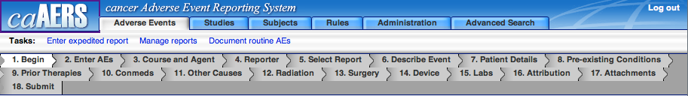
Task Menu

Section Menu

- Navigation Menu: The navigation menu allows access to the modules. To access a module, click on the tab, for example, Adverse Events.
- Task Menu: Each module may have multiple tasks associated to it, which are displayed in the Task menu. To access a task, click on it, for example, Enter expedited report.
- Sections Menu: Some tasks may have multiple sections, which are displayed in the sections menu. The section you are on is highlighted in white, for example Begin. In some modules, if you are required to enter information during that section, a green symbol, §, or a * will appear to the left of the section number. You can access a section by clicking on it. However, as you use the buttons on the page, it will automatically navigate you through the sections.
- Buttons: Many of the pages have task specific navigation buttons, which are described below.
- Back – When selected, the user will be brought to the previous page. All unsaved data will be lost.
- Save and Back – When selected, caAERS will save the data and then take the user to the previous page.
- Continue – When selected, the user will move to the next page of the application. If any information was added to the page, it will be saved.
- Save – When selected, the information on the current page will be saved to the database and the user will stay on the same page.
- Save & Continue – When selected, the information on the current page will be saved to the database and the user will move on to the next page of the application.

Expanding and Collapsing Windows
Some of the modules and tasks have areas where you can add multiple items. For example, a report can have multiple notifications, and a ruleset can have multiple rules. These areas allow you to collapse the information to provide easier navigation and viewing.
These areas are identifiable by the expanding/collapsing icon in the upper right-hand corner of the area that can expand or collapse. Currently, there are two sets of icons. See Table 3-4 for examples of the icons.
Click to expand | Click to collapse
Table 3-4 Expanding and Collapsing icons

Additional Icons
On different pages where you have the ability to add multiple sections, for example, rules to a ruleset, you may see a + and/or x next to a field or window. The + allows you to add another item. The x allows you to delete the item.
Some windows might also have a X in the upper right-hand corner. This allows you to completely remove the item, for example, removing a rule from a ruleset, or a notification from a report definition.

Help
caAERS has four types of help:
- Instructions for the module/task
- Instructions for a field
- In-line
- Online help

Instructions for the module/task
When you select a module or a task, you will often see instructions at the top of the screen explaining the purpose of the module and what information you need to supply.
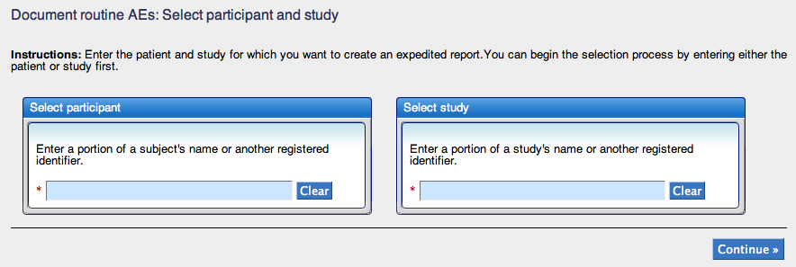

Instructions for a field
Similarly, some fields on a page for a module or task will include instructions concerning the information you need to provide.

In-line
Some fields will not have visible instructions. However, they may have the help icon, , next to the field. If you mouse over this icon, additional information will be provided.

Online Help
There is online help available for most modules. To access the help, click on the icon, , located in the top right-hand corner. The help for the page you’re on will appear in another browser or on a separate tab. An index of the help content will also appear on the left-hand side of the window.

Miscellaneous Interface features
There are a few other interface features worth noting. These features are:
- Auto-complete functionality
- Search function
- Required fields/missing information

Auto-complete functionality
Several caAERS fields are built with an auto-complete function, similar to what you find when using Google search. If a field has auto-complete enabled, it will bring up a list of possible matches when you start to type. For example, if you type can in a field with auto-complete enabled, you will get a list of possible matches such as what’s shown in the picture below.
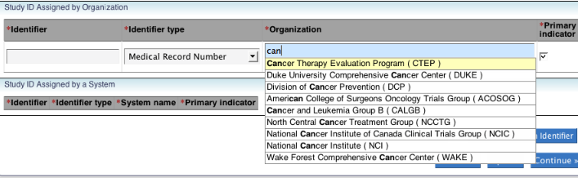
Fields with auto-complete enabled have a blue background while the other fields are grey, making these fields easy to recognize.

Search functionality
There are two main search areas in caAERS: the Advanced Search Module, which has tasks associated to many of the modules, and search functionality directly associated to modules and tasks. To search for information, choose the appropriate search and then click Search. Most fields you can leave blank before searching to see all results. If the field requires an entry, you can search for % (the percent sign) to have it display all results. You can also enter information into the search field to narrow down the search.
Once a search is completed, the results are displayed and you can choose the item you want. If there are too many results, there are filter fields for each field displayed, allowing you to further narrow down the results until you find the item you are looking for.

Required fields/missing information
As you use caAERS, you will find many of the tasks require you to add information before you can save or make changes. Required Information is identified by a red asterisk (*) to the left of the title (both field and section).
If you try to continue without including all required information, you will receive error messages indicating what information is missing. These error messages will appear in two locations, listed together at the top of the page and listed individually under the appropriate field.
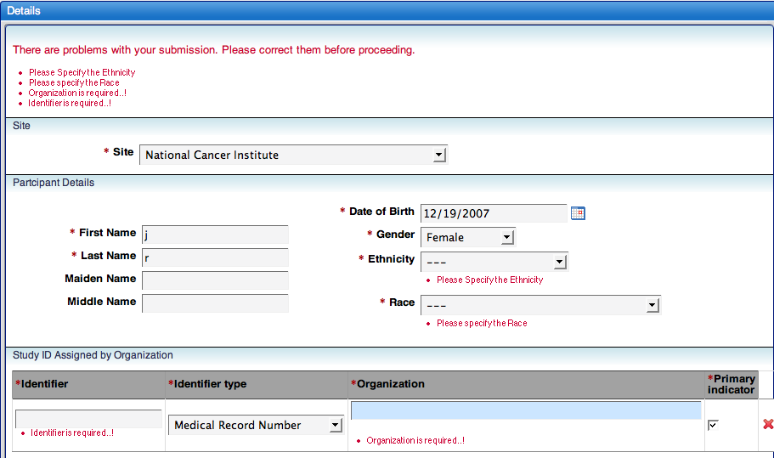

User Roles
This chapter provides an overview of user roles in caAERS. Topics in this chapter include:
- User Roles
- Roles to Tasks

User Roles
The five user roles of caAERS provide access to different modules of the application. When your account is created, you can be assigned one or more user roles, depending on your responsibilities. The roles and their responsibilities are:
- System Administrator (super user) – Responsible for maintaining the caAERS hardware and software; has access to all modules in caAERS; resolves user issues
- Site Coordinator – Responsible for maintaining information about the site
- Study Coordinator – Responsible for setting up the study in the system, creating the protocols, defining adverse events, and setting the general parameters of a study
- Adverse Event Coordinator – Responsible for entering adverse events as they are defined by the study or sponsor
- Subject Coordinator – Responsible for adding subjects and may also report adverse events
In addition to the user roles that allow access to caAERS, there are two other roles that do not have access to caAERS but are necessary for the proper use of caAERS. These user roles are:
- Study Subject – a qualified patient enrolled in a study
- Investigator – person or organization who is leading a study
Note: If an investigator wants to/needs to access caAERS, an account can be created for him/her. However, investigators are not required to have caAERS access.

Roles to Tasks
As stated previously, each role provides access to different caAERS modules. When you log in to caAERS, you will only see the modules and tasks you have access to.
The following matrix (Table 4-5) shows what modules and tasks a user role has access to. If there is a √ in the box, it means that role has access to that task.
If you feel you have not been assigned to the proper user role(s), contact the Site Coordinator or System Administrator.

 | System Admin | Site Coordinator | Study Coordinator | AE Coordinator | Subject Coordinator
AE Module
Manage Reports (View AEs) | √ | √ (for assigned studies) | √ (for assigned studies) | √ (for assigned studies) | √ (for assigned studies)
Create/Edit AEs | √ |  |  | √ (for assigned studies) | √ (for assigned studies)
Studies Module
Create/Edit | √ | √ | √ |  | √ (for assigned studies)
View | √ | √ | √ |  | √ (for assigned studies)
Subjects Module
Create and Assign/Edit | √ |  |  |  | √ (for assigned studies)
View | √ |  |  |  | √ (for assigned studies)
Rules Module
Create/Edit Rules | √ | √
View Rules | √ | √
Create/Edit Report Defs | √ | √
View Report Defs | √ | √
Administration Module
Create/Edit Users | √ | √
Create/Edit Investigators | √ | √
Import Studies/Subjects | √ | √
Import AEs | √ | √
Import Subjects | √ | √
Import MedDRA | √ | √
IND # | √ | √
Create/Edit Organizations | √ | √
Configure Password Policy | √ | √
Table 4-5 Matrix of access to modules and tasks by user role

Studies module
This chapter provides an overview of the studies module. caAERS is used to track adverse events that occur in studies, so the studies must be added. All users can do this manually through the studies module (except the Adverse Event Coordinator). Studies can also be imported from the local clinical trials management system. For information on importing studies, see the caAERS Administration Guide.
Topics in this chapter include:
- Creating a Study
- Searching for a Study
- Editing a Study

Creating a Study
Creating a study is separated into 10 sections:
- Details
- Therapies
- Agents
- Treatment Assignments
- Disease
- Sites
- Investigators
- Personnel
- Identifiers
- Overview
To start the process, select Studies from the Navigation Bar. This will open the Create Study task on the Details section.
Note: If you can’t completely enter the study in one sitting, complete the section you are on and then click the Overview section tab. This will allow you to save the study. To finish entering the information into the study, you can then search for the study and edit it.

Details
The details section is where you enter the general information about the study.
- Enter {Short title} (the title that the public will know the study by)
- Enter {Long title} (the official title as provided by the investigator or sponsor)
- Enter {precis}, if desired (this is a short description of the primary purpose of the study, intended for the general public)
- Enter {Description}, if desired (this is a detailed description of the study, including information not covered by other fields, such as comparison studies)
- Select {Phase}
- Select {Status}
- Select {Yes or No} for Multi institutional
- Select {Yes or No} for AdEERS reporting required
- Select {AE coding Terminology}
- Select {CTC version}, if CTC was selected in step 9
- Select {Disease coding Terminology}
- Select {Study design}
- Select the appropriate {Report formats}
- Enter {Coordinating center} and select {center} from the list
- Enter {Coordinating center identifier}
- Enter {Funding sponsor} and select {center} from the list
- Enter {Funding sponsor identifier}
- Click Continue

Therapies
There are five therapies that can be associated with the study:
- Agent
- Device
- Radiation
- Surgery
- Behavioral
Select the checkbox next to the Therapy(s), if any, which you’ll be using in the study and then click Continue

Agents
If you select Agent as a therapy, this is the page where you will add the specific agents. If you did not choose agent, click Continue to move to the next section. To add an agent:
- Click Add Study Agent
- Type {the agent} and then select {an agent} from the list
or
Select Other and type {agent info} if the agent is something that is not in the system yet
- Select {IND Info}, if desired
- Select {Yes or No} for Lead IND
- Click Add Study Agent to add another agent; to delete an agent, click the x in the upper right-hand corner of the Study agent area
- Click Continue when you’ve added all agents
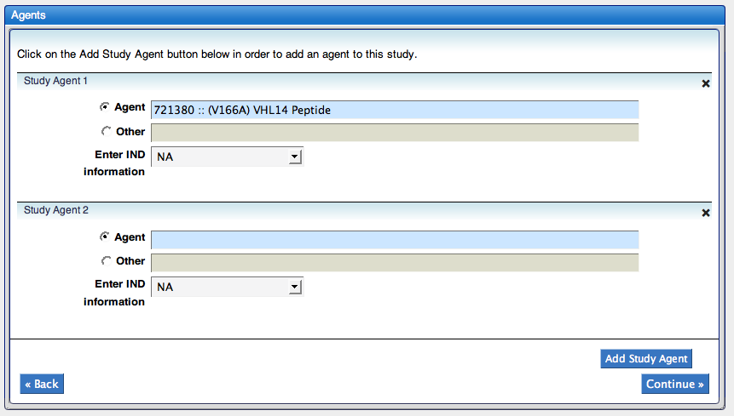

Treatment Assignments
Your study may have treatment assignments (arm/cohorts) associated with it. If this is the case, you’ll want to add those on this page. If you don’t have treatment assignments associated to this study, click Continue to move to the next section. To add a treatment:
- Click Add Treatment Assignment
- Type {the code}
- Type {the dose level order}, if desired
- Type {a description}
- Type {comments}, if desired
- Click Add Treatment Assignment to add another treatment; to delete a treatment, click the x in the upper right-hand corner of the Treatment Assignment area
- Click Continue when you’ve added all treatments
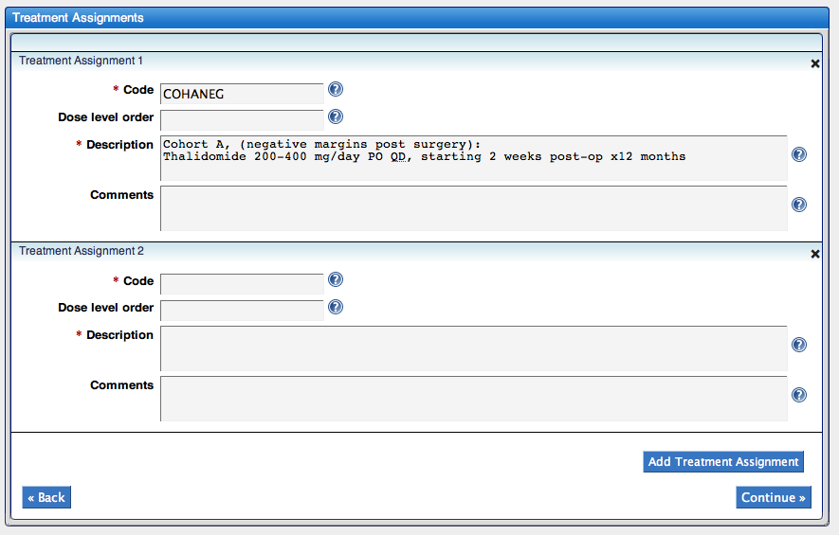

Disease
The Diseases section is where you add diseases that you want associated to your Study. If there are no diseases associated with your study, click Continue
- Type {category search term} and select {the disease category} that matches your search
- The Sub Category and Diseases fields will have populated with information that matches the category you selected. Select {sub category} to narrow down the Diseases list.
- Select {Disease} and click Add disease;
Note: if you select All and then click Add disease, it will add all the diseases in the list
- To select another disease from the provided list, select {Disease} and click Add disease
or
To select another disease from a different category, click Clear and repeat steps 1-4
- To remove a disease from the Selected Diseases list, click the red x next to it
- To make a disease a primary disease, select the checkbox next to that disease in the Selected Diseases list
- Once you added all the diseases, click Continue
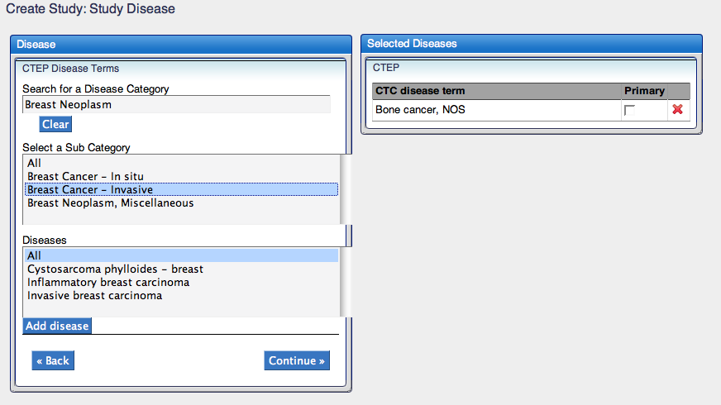

Sites
Sites are added to the study on the Sites page. All studies require at least one site, but can have more assigned to it. To assign a site:
- Click Add Study Site
- Type {site name} and select {the site} from the list provided
Note: If the site is not listed, contact the System Administrator
- To select another site, select Add Study Site
- To remove a site, click Delete
or to clear the site information and add a different site, click Clear
- Once you add all the sites, click Continue
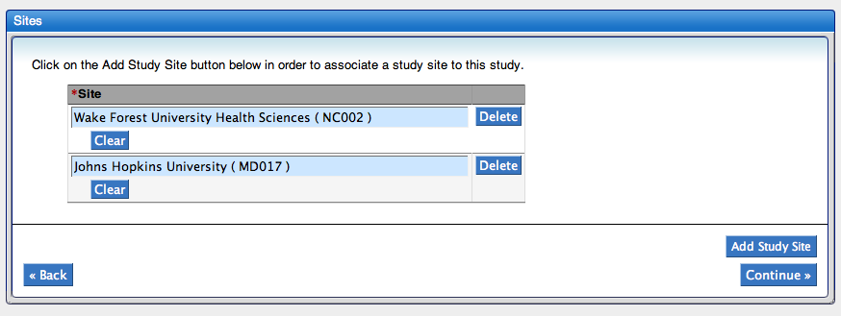

Investigators
All studies require an investigator to be associated with it. This can be a principal investigator, a site principal investigator, or a site investigator. The investigator can come from a site, the coordinating center, or the sponsor. To add an investigator:
- Select {a site}
- The investigator associated with that site may come up. If not, click Add Investigator
- Type {investigator name} and select {the investigator} from the list
- Select {role}
- Select {status}
- To add another investigator from the same site, repeat steps 2-5
or
To add another investigator from a different site, repeat steps 1-5
- A summary of investigators to site appears to the right of the page. To review, select {a site}; to delete an investigator, click Delete next to the investigator’s name; once you have added the investigators, click Continue
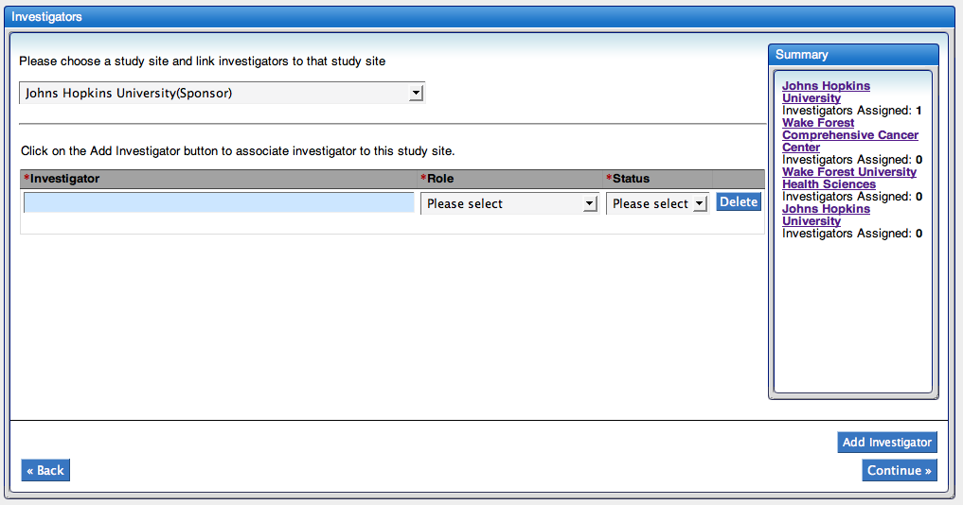

Personnel
Research staff can be associated to a study. The roles associated are Subject Coordinator, Study Coordinator, and Adverse Event Coordinator. The research staff can come from a site, the coordinating center, or the sponsor. To add staff to a study:
- Select {a site}
- The staff associated with that site may come up. If not, click Add Research Staff
- Type {staff name} and select {the person} from the list
- Select {role}
- Select {status}
- To add another research staff from the same site, repeat steps 2-5
or
To add another research staff from a different site, repeat steps 1-5
- A summary of the research staff to the sites appears to the right of the page. To review, select {a site}; to delete a research staff, click Delete next to the staff’s name; once you have added all research staff, click Continue
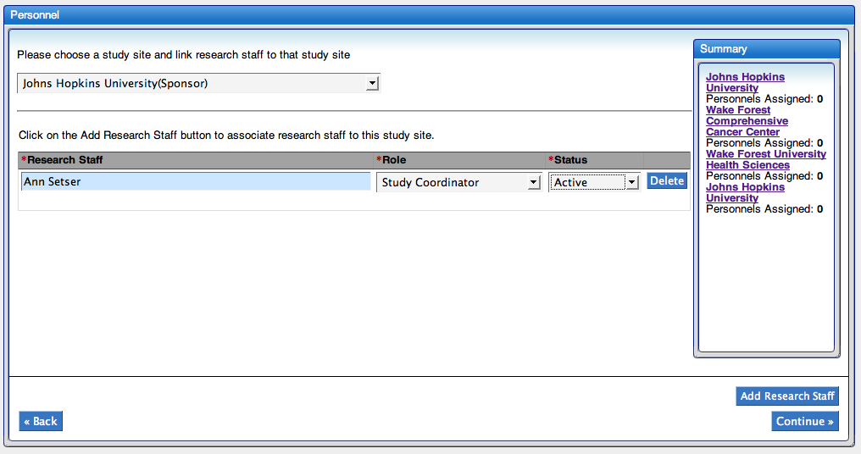

Identifiers
There are two types of study identifiers used in caAERS, Organization and System. Organization Identifiers identify the study with the different Organizations involved and are generally the identifier used for most studies. System Identifiers identify the study with different systems, such as caBIG.
caAERS will have automatically add two Identifiers for Organization, based on what you entered for Coordinating Center and Funding Sponsor on the Details page, with the Coordinating Center being the primary indicator. If these identifiers aren’t adequate to identify the study, you can add additional Organization and System Identifiers.
To add an Identifier:

By Organization
- Select Add Organization Identifier
- Type {Organization name} and select {the organization} from the list
- Select {Identifier type}
- Type {Identifier}
Note: the first part of the identifier an be found either in parentheses after the organization name or at http://ctep.cancer.gov/forms/Organization_Codes.txt
- To mark it as the Primary Indicator, add a checkmark in the Primary Indicator column
Note: There must be a primary indicator, and there can only be one primary indicator
- To delete an identifier, click Delete next to the identifier; to add another Organization Identifier, repeat steps 1-5; to add a system identifier, see By System for instruction
- Click Continue

By System
- Select Add System Identifier
- Type {System name}
- Select {Identifier type}
- Type {Identifier}
- To mark it as the Primary Indicator, add a checkmark in the Primary Indicator column
Note: There can only be one primary indicator
- To delete an identifier, click Delete next to the identifier; to add another System Identifier, repeat steps 1-5; to add an Organization identifier, see By Organization for instruction
- Click Continue
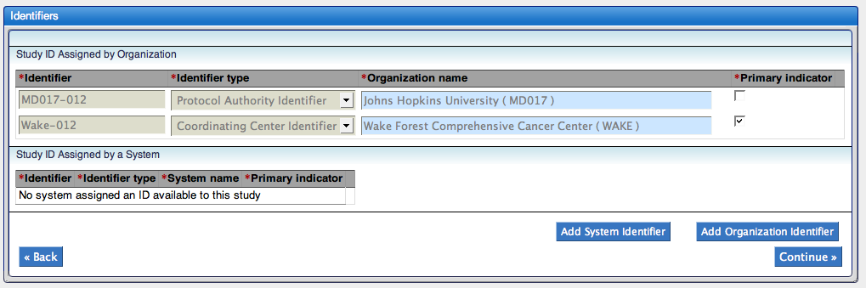

Overview
The Overview page summarizes all the information entered about the study. Review the information provided. If there are changes that you need to make, click Back or click {the section} that contains the information that needs to be changed. If the study is complete, click Save.
A confirmation page will be displayed showing the short title, primary identifier, coordinating center, funding sponsor, and phase.
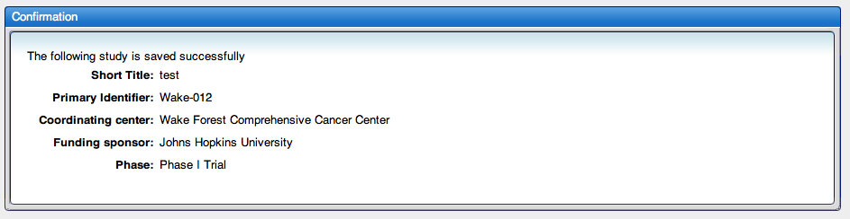

Searching for a Study
The studies module also has a search features that allows you to search for studies. You can search for a study based on the study’s Short Title, Primary Identifier, or Status.
To search for a study:
- Click Search Studies from the Task menu
- Select {search by} from the drop-down list
- Type {your search criteria} in the Search By: field and then click Search
Note: You can also type % to list all Studies
- The Studies available will be listed. You can further refine the search by typing something in the Primary ID, Short Title, Funding Sponsor, Phase, and/or Status filter areas and then click Filter
- To view the study and/or make changes to it, click on {the short title} or {the primary id}
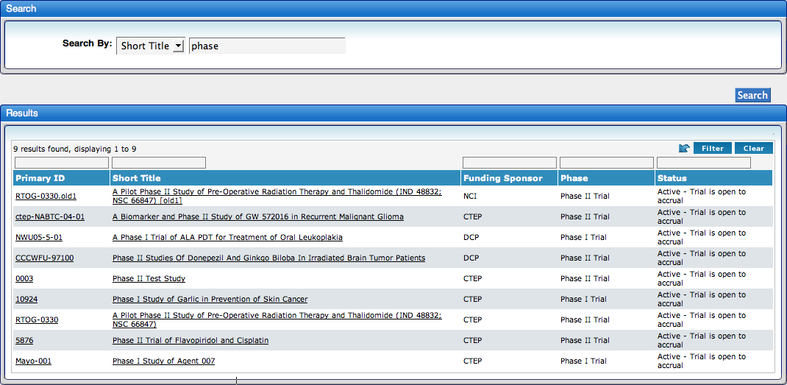

Editing a Study
Studies can be edited after they are created. First, search for the study and select it. This will open the create study task, with the information filled in. Select the section that contains the information you need to edit, make the changes, and chose Save or Save & Continue. For step-by-step instructions, see Searching for a Study and Creating a Study.

Subject module
This chapter provides an overview of the Subjects module. Subjects are people enrolled in a clinical study. They must be added to caAERS before a routine or serious adverse event can be recorded. This can be done through the subject module by the Subject Coordinator (see Chapter 4 - User Roles). Subjects can also be imported into caAERS, as described in the caAERS Administration Guide.
Topics in this chapter include:
- Creating a subject
- Assigning a subject to a study
- Searching for a subject
- Editing a subject

Creating a Subject
There are three sections for adding a subject:
- Details
- Choose a Study
- Review

Details
The details section is where you add general information on the subject and add an identifier.
- Select {Site}
- Enter {First Name}
- Enter {Last Name}
- Enter {Maiden Name} if desired
- Enter {Middle Name} if desired
- Enter {Date of Birth yyyy mm dd)} Optionally, you can enter just the year of birth and not the full birth date
- Select {Gender}
- Select {Ethnicity}
- Select {Race}
- Determine if you are entering a System Identifier or Organization Identifier (caAERS automatically displays the Organization Identified fields). If you are entering an Organization Identifier, enter the {Identifier}, select {Identifier Type}, and enter {Organization}. Select Primary Indicator if necessary.
or
If you are entering a System Identifier, click the red X next to Organization Identifier and click Add System Identifier. From there, enter the {Identifier}, select {Identifier Type}, and enter {System name}. Select Primary Indicator if necessary.
- If there is more than one Identifier, click Add System Identifier or Add Organization Identifier and repeat step 10.
- Select Primary Indicator for only one Identifier, and then click Continue to select a study
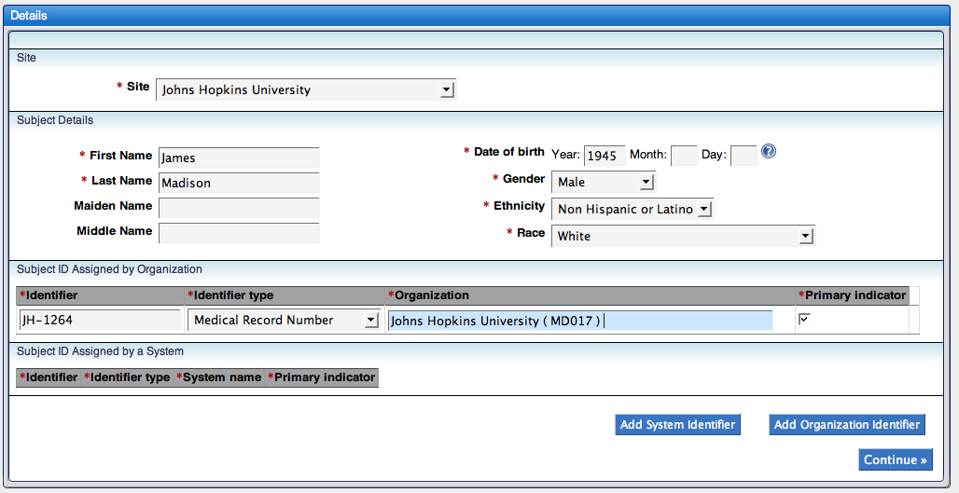

Choose Study
You can select studies to search for by title or identifier. Once the studies are listed, you can select one or more before continuing.
- Select {Search Type}
- Enter {search criteria} (at least one character or % to list all) and click Search
- The studies that match your search will be listed under Choose Study. Select the study or studies the subject is associated to and then click Continue

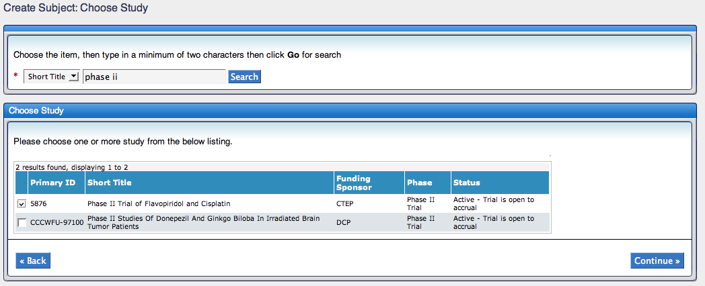

Review
- Verify the information entered is complete and then click Save. If you need to make changes, select Back to return to the previous sections.

Assign a Subject to a Study
You can add a subject to another study in caAERS at any time using the Assign Subjects to Studies task. You can make the assignment by either searching for a subject or searching for a study.
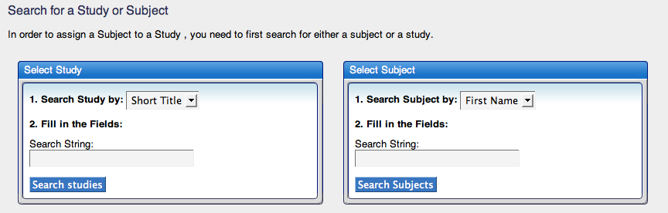
Note: This method allows assignment to one study at a time, so if there are multiple studies the subject needs to be added to, you will repeat this task.

Assignment by Selecting a Study

Search Study
- Select {Study criteria}
- Enter {Search criteria} and click Search Studies
- Select {the study}, select the {corresponding site}, and then click Save & Continue
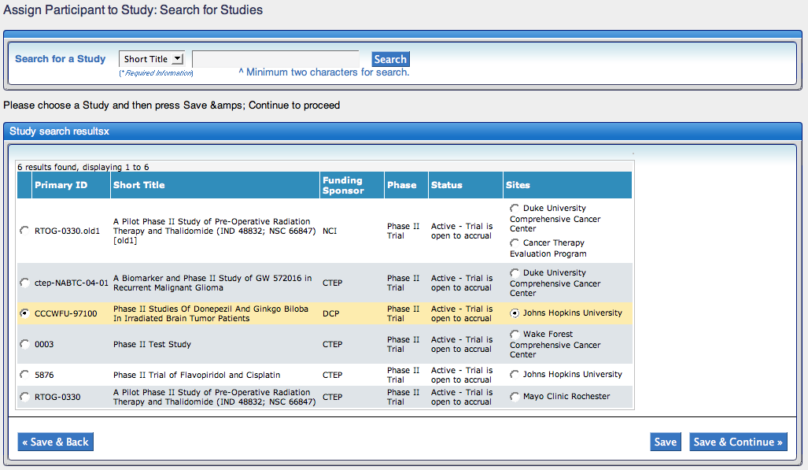

Search Subject
- Select {Subject criteria}
- Enter {Search criteria} and click Go
- Select {the subject} and click Save & Continue

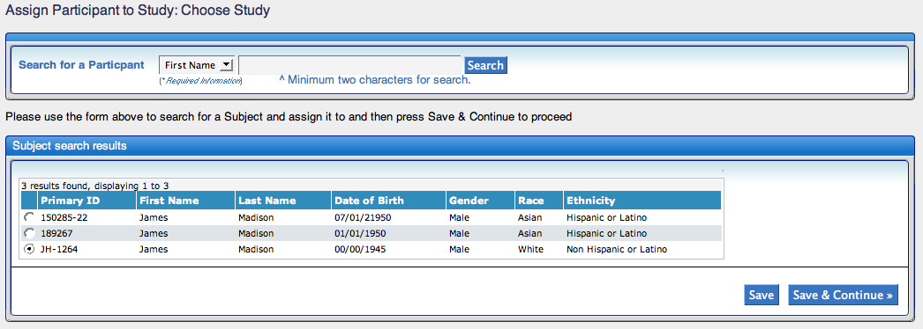

Review and Submit
- Review the information to verify the study selected. If it’s correct, click Save; if not, click Save & Back to go back and make changes

View Subject
- After you click Save, the View Subject page appears and shows all the studies the subject is assigned to as well as the subject’s details. To assign to another study, click the Assign Subjectss to Studies task under the Subjects module.

Searching for a Subject

Searching Subject
- Select {Subject criteria}
- Enter {Search criteria} and click Search Subjects
- Select {the subject} from the results and click Save & Continue

Search Study
- Select {Study criteria}
- Enter {Search criteria} and click Go
- Select {the study}, select the {corresponding site}, and then click Save & Continue

Review and Submit
- Review the information to verify the study selected and patient assignment. If it’s correct, click Save; if not, click Save & Back to go back and make changes

View Subject
- After you click Save, the View Subject page appears and shows all the studies the subject is assigned to as well as the subject’s details. To assign to another study, click the Assign Subjects to Studies task under the Subjects module.

Searching for a Subject
The user can search for subjects to see if they have already been added to caAERS and then make changes to their general information. To change the studies the subject is assigned to, see the Assign Subjects to Studies section of this chapter.
To search for a subject:
- Click Search/Edit Subject from the Subject module
- Enter {search criteria} in the Identifier, First Name, and/or Last Name, field and then click Search
Note: You can also just click Search to list all subjects
- The subjects in the system will be listed. You can refine the search results by typing something in the First Name, Last Name, and/or Primary ID filter areas and then clicking Filter
- To view the subject and/or make changes, click on {the first name} or {the primary id} in the search results
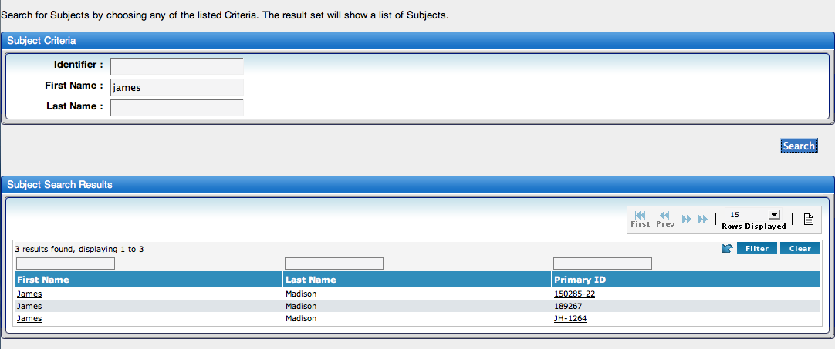

Editing a Subject
Subjects can be edited after they are created. First, search for the subject and select him/her. This will open Review section of the create subject task, with the information filled in. Select Details to modify the information, and chose Save. For step-by-step instructions, see Searching for a Subject and Creating a Subject.

Adverse Events module
This chapter provides an overview of the Adverse Events module. caAERS is used to report and document any AEs that occur during clinical trials. There are two different types of AEs, Serious AEs and Routine AEs. Serious AEs are tracked through the Enter expedited report task and Routine AEs through the Document routine AEs task.
What someone considers a Routine AE may actually be a Serious AE. As you document the AE, your entries will trigger rules behind the scene that will force you to enter an Expedited Report. The information from the routine AE will be included in the expedited report, so you don’t have to duplicate your work.
Topics in this chapter include:
- Entering an Expedited Report
- Documenting routine AEs
- Managing Reports

Enter an Expedited Report
The primary purpose of caAERS is the entering of AEs, both routine and serious. The Expedited Report task includes reporting for both serious and routine AEs.
There are multiple sections to entering an expedited report. In general, sections 1-7 are required, while 8-17 may be optional, based on the study and AE. After you select the reports (section 5), caAERS will identify which other sections have mandatory fields.
To create an expedited report, click Enter expedited report and then follow through the sections. The sections for creating an expedited report are:
Section # | Title |  | Section # | Title
1 | Begin |  | 10 | Conmeds
2 | Enter AEs |  | 11 | Other Causes
3 | Course and Agent |  | 12 | Radiation
4 | Reporter |  | 13 | Surgery
5 | Select Report |  | 14 | Device
6 | Describe Event |  | 15 | Labs
7 | Patient Details |  | 16 | Attribution
8 | Pre-existing Conditions |  | 17 | Attachment
9 | Prior Therapies |  | 18 | Submit

Begin
The first step of entering an expedited report is selecting the subject and study.
- Begin typing the subject’s {name} and select {the subject’s name} from the list when it appears
- Begin typing the {study} and select {the study} from the list when it appears
- Click Continue
Note: You can select the study first – the order does not matter
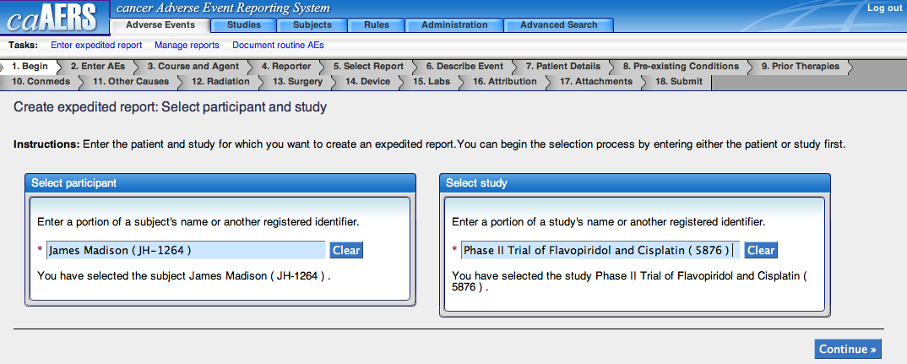

Enter AEs
AEs are entered on the Enter AEs page. This page will look different based on the vocabulary chosen for the study (CTC or MedDRA). All AEs can be added on this page (SAE and AE), you don’t need to create a separate report for each AE.
To add an AE:
- Select {CTC category}, typing the {CTC term} and select {the term} from the list when it appears
Note: You can click Show All to see all CTC terms associated to the category you selected
or
Begin typing the {adverse event} and select {the MeDRA term} from the list of potential MeDRA terms
- Select {the level of severity} of the Adverse Event
- Enter {start date (mm/dd/yyyy)}, if desired
Note: This is required for the primary AE
- Enter {end date (mm/dd/yyyy)}, if known
Note: This may not be known, so is not always required. If it’s required and you’ve left it blank, you will receive a message before you can proceed.
- Select {how likely the AE is related to the agent}; is this adverse event possibly caused or related to any intervention in the study
- Did this AE result in hospitalization or prolongation of hospitalization? Select the appropriate answer
- Was this AE an expected result? Select {Yes or No}
Note: When the study is testing a single commercial agent, if it was expected will be indicated in the package insert. If this is a single agent (Phase 1 trial), expected AEs will be defined in certain sections of the protocol and brochure. You may also find information on expected AEs in the AdEERS Agent Specific Adverse Event List (ASAEL) and in the informed consent documents.
- Provide additional information about the adverse event term in the Comments field.
- If you want to add another AE, click Add another AE and repeat steps 1-8; click Continue when you have added all AEs
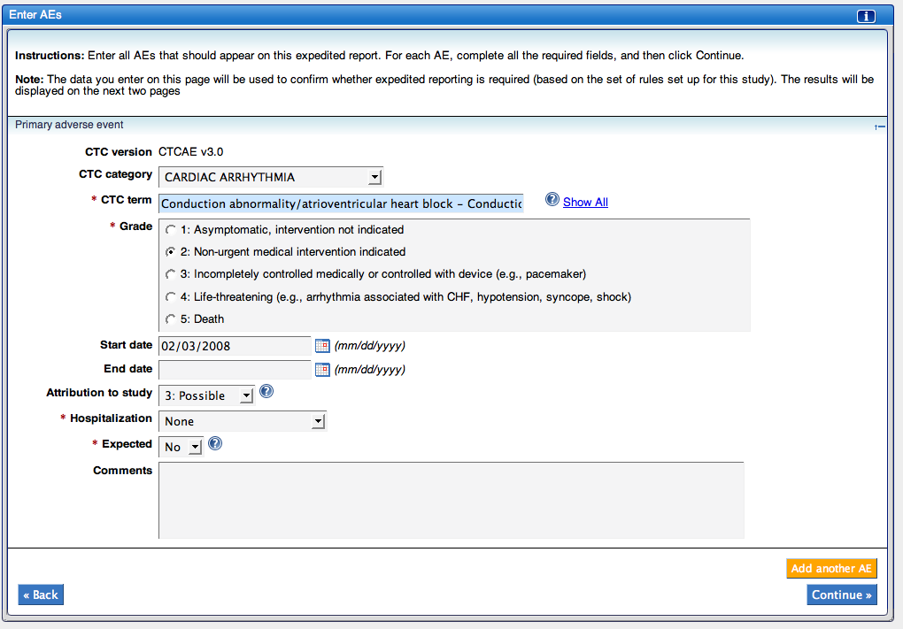

Course and Agent
Treatment information on the course and agent the subject received during the AE is necessary to see how the treatment information is related to the AE. Knowing what agents, dosage, etc the patient was receiving at the onset of the AE helps determine that relationship. To enter treatment information:
- Select the {treatment assignment code} from the dropdown list; if the dose level is not listed/has not been extracted for the arm, select Enter a description of treatment assignment or dose level and then type {the treatment assignment and dose level}
- Enter {start date of first course (mm/dd/yyyy)}
- Enter {start date of course associated with the report (mm/dd/yyyy)}
- Enter {course number on which event occurred}
- Enter {total number of course to date}
- Click Add a study agent
Note: You will repeat steps 6-13 multiple times, adding all agents for the dose level/treatment arm indicated. You must include information on all the agents the subject was supposed to get
- Select {Study Agent}
- Enter {total dose administered this course}
- Select {Unit of measure}
- Enter {date last administered (mm/dd/yyyy)}
- Enter {the quantity of time} and select {measurement}, if there was an administration delay
- Enter {Comments about admin delay and modified dose}, if applicable
- Select {Dose Modified} if the dose was altered relative to the dose level/treatment arm and then enter the {Modified Dose} and select {units}; for example, if the total dose was supposed to be 300mg (3 days in a row of 100mg a day), but the 3rd day the subject was only given 50 mg, you’d select Dose Modified and enter 50 mg, and enter “Only gave 50 mg on 3rd day) in the comments field
- If there’s another study agent you want to provide information on, click Add a study agent and repeat steps 7-13
or
click Continue
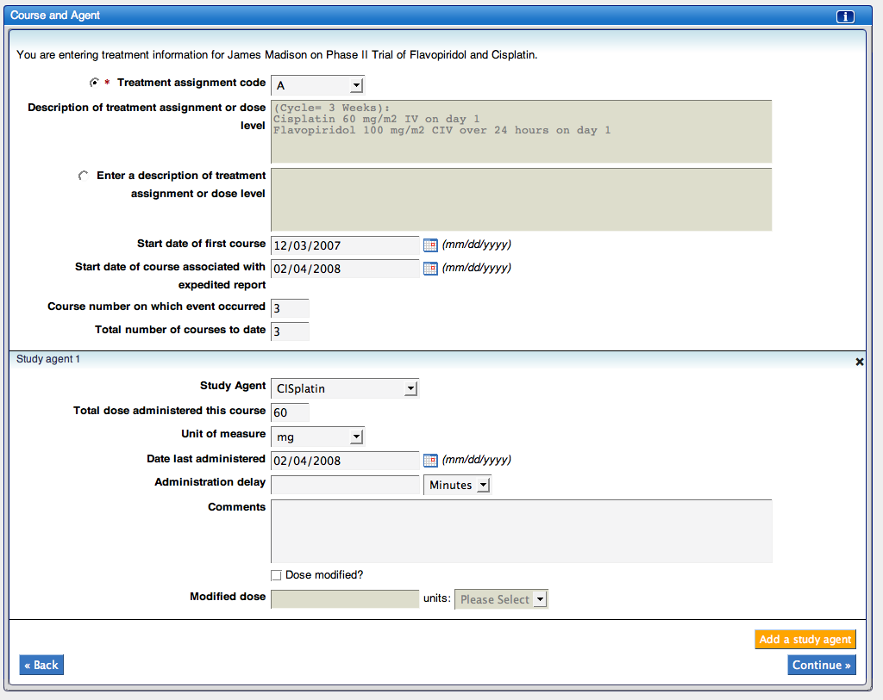

Reporter
You need to capture who did the data entry on the AE. This is the information captured on the Reporter page.
Note: If the information provided in the previous sections does not match the requirements for an expedited report, you will receive a message on this page giving you the option to continue or save the AE as a routine report.
To enter reporter details:
- If the person entering the information is associated to the study, select {their name} from the Research Staff list
Note: if you select someone from this list, the required fields will automatically be populated by information in the system. If the person is not listed, continue to step 2
- Enter {First name}
- Enter {Middle name}, if desired
- Enter {Last name}
- Enter {e-mail address}
- Enter {phone number}, if desired
- Enter {fax number}, if desired
To enter physician details:
- If the physician is the person entering the AE information, select Physician is same as the reporter; If not, continue to step 9
Note: this will copy the information from the Reporter details section into the physician details section
- Enter {First name}
- Enter {Middle name}, if desired
- Enter {Last name}
- Enter {e-mail address}
- Enter {phone number}, if desired
- Enter {fax number}, if desired
- Click Continue
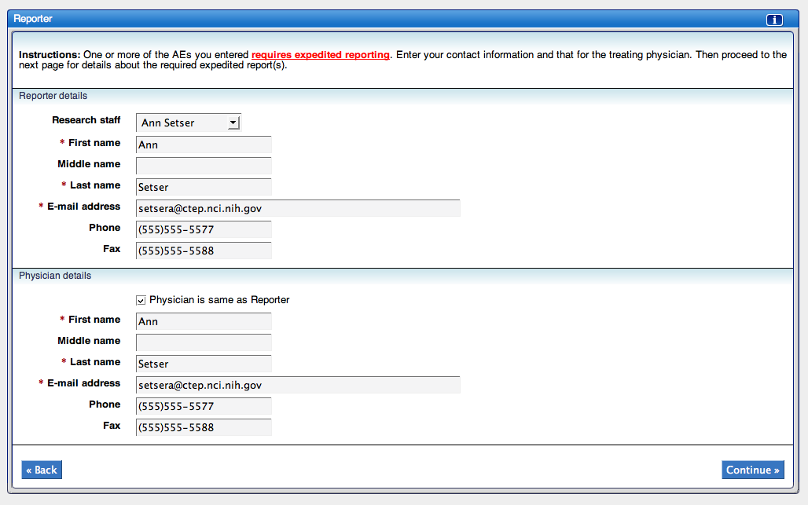

Select Report
During study setup, and based on rules set up by the sponsors, investigator, or others, certain reports will be mandatory. Mandatory studies will automatically be selected and grayed out. If you want to add additional reports, you can do so in this section. To select a report:
- Select each required {reports}
Note: Mandatory reports will be grayed-out and can’t be selected or unselected
- Click Save to save the changes but not initiate the countdown for the reports; click Save & Continue to initiate the countdown for the due dates of the report(s)
Note: You may also see Manually select reports. Clicking this will allow you to override the system and select additional reports. It is possible this option will be there when you first access the page, but it may not appear until you save the page. If you want to manually select reports, click Manually select reports and click Ok on the message that comes up. You can then make additional changes to your report selections
Note: Once you’ve saved this page, any additional fields that are required will be marked with * and sections with required fields will have § and/or * to the left of the section number. The remaining pages/sections will allow you to add a form to provide additional information. If you do add a form and there is required information, you will not be allowed to move forward until the required information has been populated.
- Once you’ve clicked Save, your selections will be grayed-out, like the mandatory fields. If you want to make changes, go to another section, then return to Select Report. From here, click Manually select reports and click Ok on the message that comes up. You can then make additional changes to your report selections
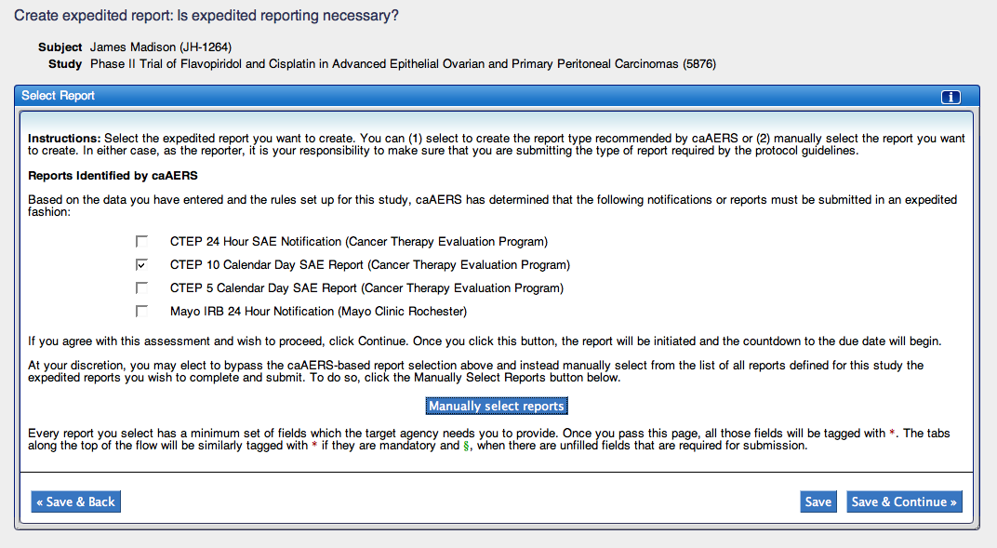

Describe Event
A description of the event must be included with the report. You will describe the presentation of event, clinical findings, the treatment of events, and the timing of the events related to agent administration or investigation administration. To describe the event:
- Enter {Description}; include information on the presentation of the event, clinical findings, treatment of the event, and timing of the event related to agent administration
- Select {Present status}
- Enter {date of recovery or death (mm/dd/yyyy)}, if applicable
Note: this field may be mandatory, depending on information provided in other fields. If it is required, you will see an error stating so when you try to move to the next section
- Select {Yes or No} if the agent was reintroduced or given to the subject again
- If the patient was removed from the protocol, enter the {date (mm/dd/yyyy)} he/she was removed
- If applicable, select {Yes or No} if the blind-study was broken
- If applicable, select {Yes or No} if the study drug was stopped, interrupted, or reduced
- If applicable, if the dose was reduced, enter {new dose}
- Enter {date of recovery or death (mm/dd/yyyy)}, if applicable
- Enter {number of days not given} if the dose was interrupted
- If applicable, select {Yes or No} if the event abated after the study drug was stopped or dose reduced
- If applicable, select {Yes or No} if the event reappeared after the study drug was reintroduced
- Click Save or Save & Continue
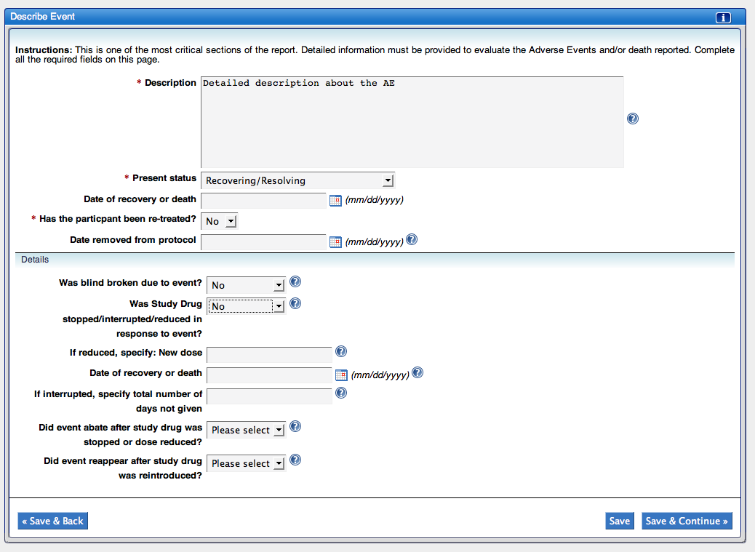

Patient Details
When a patient is added to caAERS, general information is provided for that patient. However, when an AE occurs, additional information is required. To enter patient details:
- Enter {height} and select {units}
- Enter {weight} and select {units}
Note: Body surface area will automatically be calculated after enter height and weight; enter the information in either Inches and Pounds or Centimeters and Kilograms, do not mix the two units of measurement
- Select {Baseline performance}
- Select {Disease name}
or
enter {Disease name} if there is nothing in the drop-down
- Start typing the {primary site} of the disease and select the {site} from the list when it appears
or
enter the {primary site} of the disease if there is nothing/no match in the list
- Enter {date (mm/dd/yyyy} of the initial diagnosis
- If there is metastatic disease information to add, go to step 8, if not, click Save or Save & Continue
- Click Add a metastatic site
- Start typing the {metastatic site} and select the {Site} from the list when it appears
or
Select Other and Enter {metastatic site}
- To add another metastatic site, click Add a metastatic site and repeat steps 9-10
or
Click Save or Save & Continue
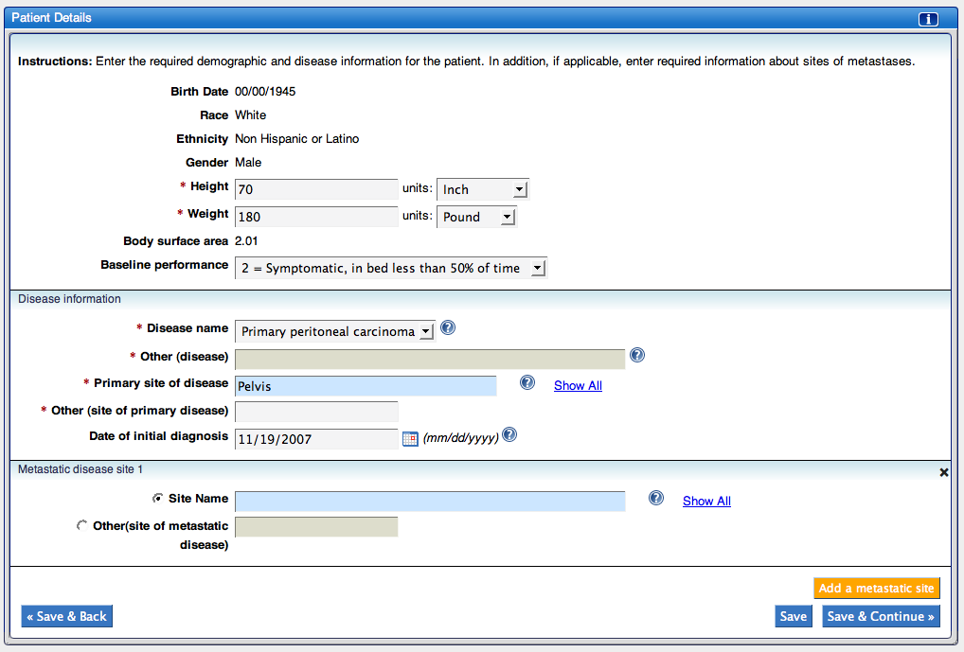

Pre-existing Conditions
If the patient has any relevant medical history, add the information to the report. To add a relevant medical history:
- Click Add a Pre-Existing Condition
Note: This list is based on MedDRA
- Select the {Condition}
or
If there isn’t a match in the pre-existing condition field, type in the {condition} in the Other field
- To add additional medical history, repeat steps 1-2
or
to delete a pre-existing condition, click the x in the right corner of the window
or
Click Save or Save & Continue
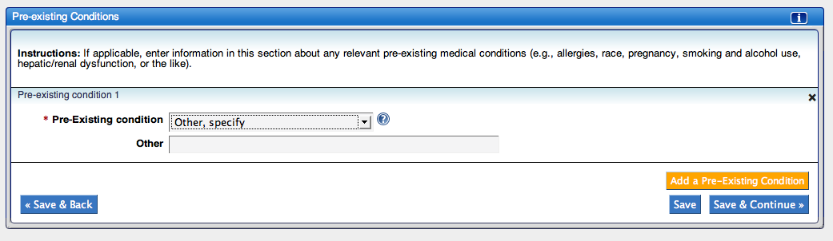

Prior Therapies
Prior therapies for the primary disease need to be recorded. If the information is relevant, prior therapies for non-primary diseases should also be entered. To enter a prior therapy:
- Click Add a Therapy Type
Note: This list is based on the CTEP Therapy Classification
- Select {prior therapy}
- Enter {comments}, if applicable
- Enter {start date (mm/dd/yyyy)}, if desired
- Enter {end date (mm/dd/yyyy)}, if desired
- If the Add an Agent button appears, go to step 7,
else
To add another therapy, repeat steps 1-5
or
to delete a therapy, click the x in the right corner of the window
or
Click Save or Save & Continue
- Click Add an Agent
- Enter {agent} and select {agent}
- To add another agent, repeat steps 7-8
or
To add another therapy, repeat steps 1-5
or
to delete a therapy or agent, click the x in the right corner of the window
or
Click Save or Save & Continue
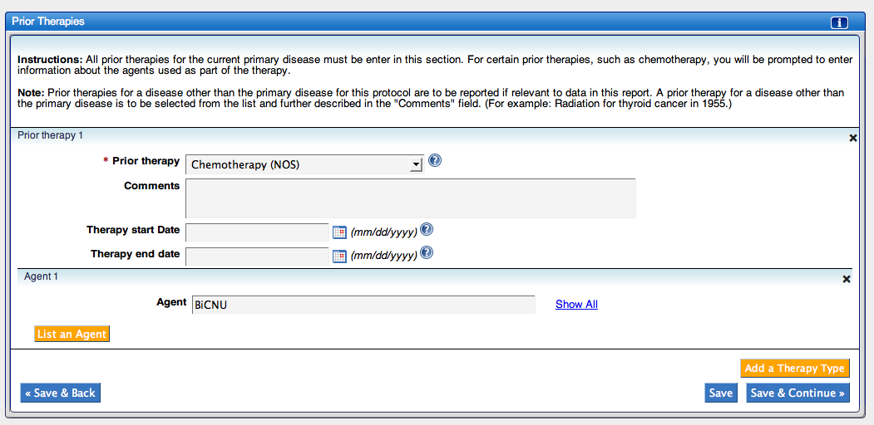

Conmeds
Concomitant Medications (conmeds) may need to be provided in the report. Document any concomitant medications that might have contributed to an event. To add a conmed:
- Click Add a medication
- Enter the {name of the medication}
- To add another medication, repeat steps 1-2
or
to delete a medication, click the x in the right corner of the window
or
Click Save or Save & Continue
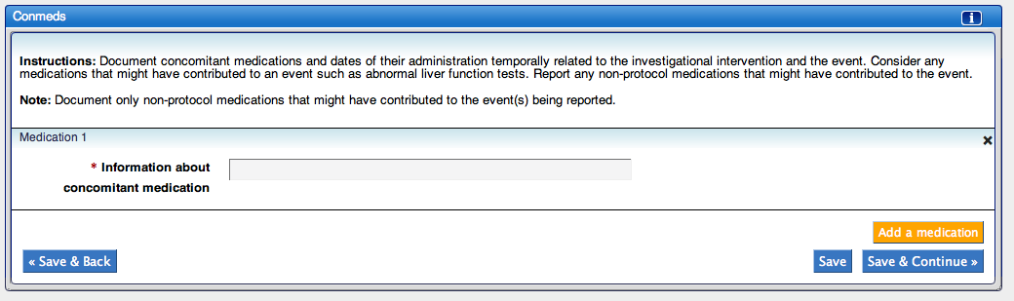

Other Causes
If there are any other circumstances that may be related to the event, they need to be included in the report. To include another cause:
- Click Add a cause
- Enter {cause details}
- To add another possible cause, repeat steps 1-2
or
to delete a cause, click the x in the right corner of the window
or
Click Save or Save & Continue
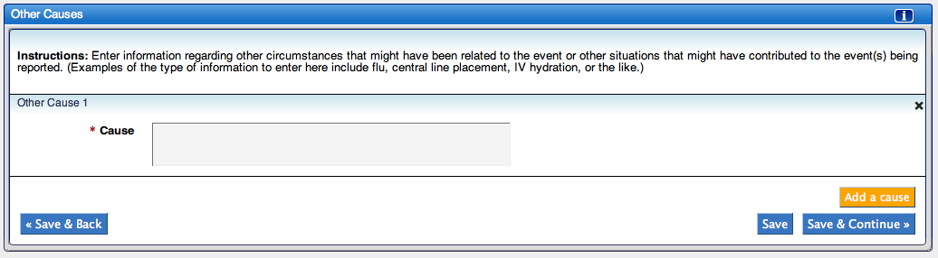

Radiation
If the study involves Radiation intervention, information about the radiation needs to be included in the report. To add radiation information:
- Click Add a radiation
- Select the {type of radiation}
- Enter the {dosage} of radiation and select {units}
- Enter {date of last treatment (mm/dd/yyyy)}
- Enter {scheduled number of fractions}
- Enter {number of elapsed days}
- If applicable, select how the radiation was {adjusted}
- Click Save or Save & Continue
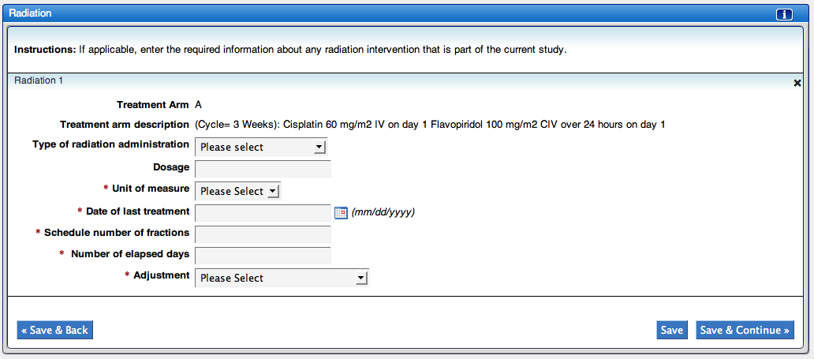

Surgery
In the course of some studies, surgery is required. The place where the surgery occurred (the intervention site) needs to be included with the report. To add a surgery intervention to the report:
- Click Add a Surgery Intervention
- Begin typing the {intervention site} and select the {intervention site} when it appears in the list
- Enter the {date of intervention (mm/dd/yyyy)}
- Click Save or Save & Continue
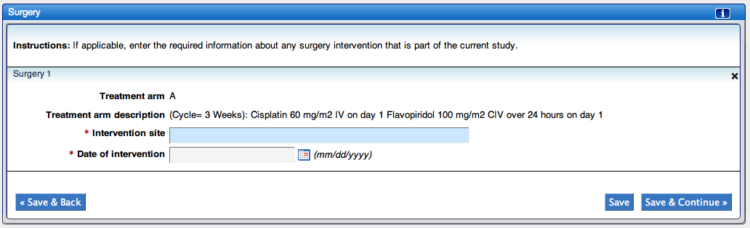

Device
If there are devices involved in the study or in an intervention, the information about the device needs to be included in the report. To add a device:
- Click Add a Medical device
- Enter {Brand name}
- Enter {Common name}
- Enter {Device type}
- Enter {Manufacturer name}
- Enter {Manufacturer state}
- Enter {Model number}
- Enter {Lot number}, if desired
- Enter {Catalog number}, if desired
- Enter {Expiration date (mm/dd/yyyy)}, if desired
- Enter {Serial number}
- Enter {Other number}, if desired
- Select {Device operator}
- Enter {Other device operator}, if desired
- Enter {Implant date (mm/dd/yyyy)}, if implanted
- Enter {Explanted date (mm/dd/yyyy)}, if explanted
- Enter {Reprocessor name}, if desired
- Enter {Reprocessor address}, if desired
- Select {Yes or No} for evaluation availability
- Enter {Returned date (mm/dd/yyyy)}
- Click Save or Save & Continue
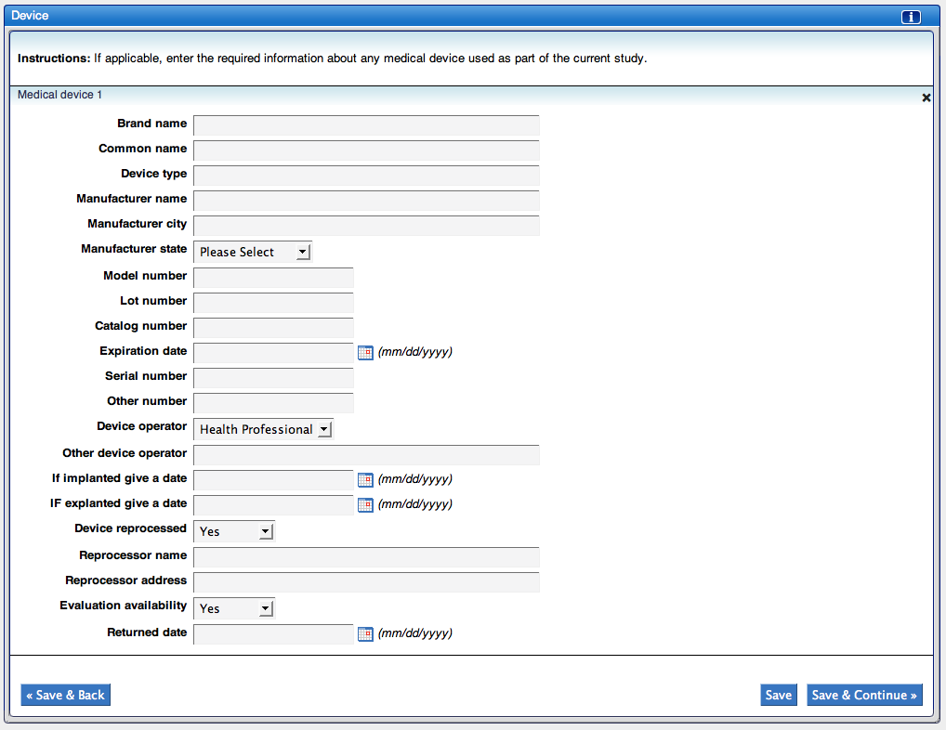

Labs
If tests were sent to a lab and are possibly related to the AE, include them in the report. To add a lab:
- Click Add a lab
- Select the {Lab category}
- Select the {Lab test name}
or
if the lab test is not listed, select Other, specify and enter the {lab test name} in the Other field
Note: If you selected Microbiology for the Lab category, go to step 8
- Select the {Units} that will be associated with the Baseline, Worst, and Recovery values
- Enter {Baseline value} and {date (mm/dd/yyyy)}
- Enter {Worst value} and {date (mm/dd/yyyy)}
- Enter {Recovery value} and {date (mm/dd/yyyy)}, if applicable and go to step 11
- Enter the {Site} associated with the lab test
- Enter the {date (mm/dd/yyyy)} of the test
- Enter {details about the Infectious Agent}
- To add another lab, repeat steps 1-10
or
to delete a lab, click the x in the right corner of the window
or
Click Continue
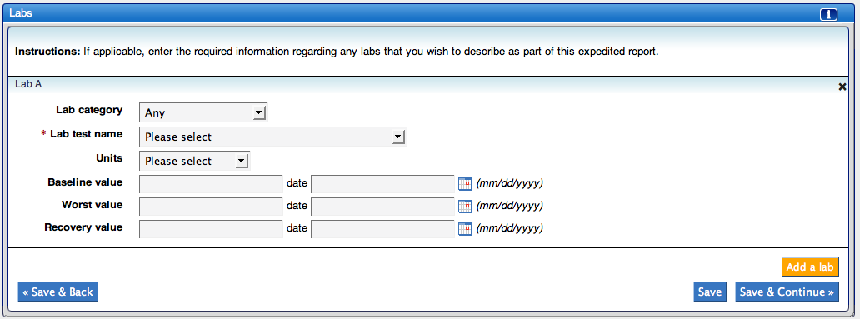

Attribution
For each AE, the reporter/physician must assign an attribution to each possible cause. At least one of cause has to be assigned an attribution of possible, probable, or definite. The possible attributions are:
- Unrelated
- Unlikely
- Possible
- Probable
- Definite
The possible causes are:
- Disease
- Course (agent)
- Surgery
- Radiation
- Medical device
- Concomitant Medications
- Other causes
Note: If a section on this attribution list is not appropriate/has not been entered, you will not have an option to select an attribution. Instead you will see a message. For example, if there was no medical device associated to this report, it would say “No medical devices for this report”.
To enter the relationship between a possible cause and an AE:
- Select {attribution} for the associated cause
- Click Save or Save and Continue
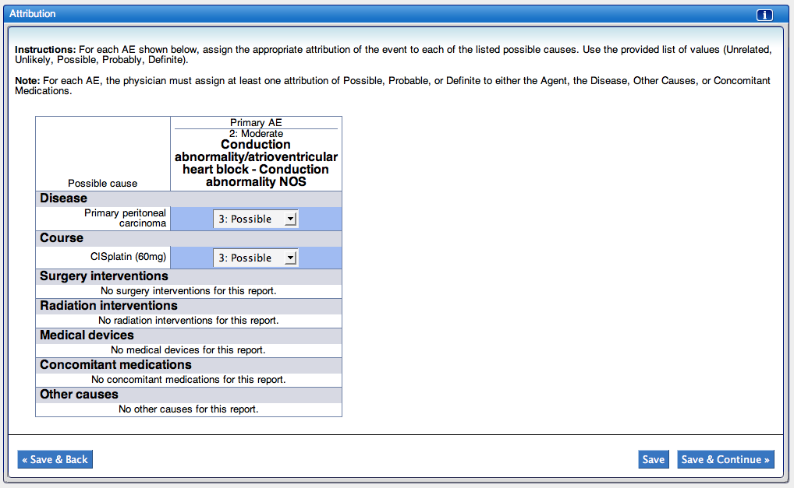

Attachment
For some reports\Adverse Events, it may be beneficial to submit additional information to help clarify the information provided in the report. In this section, identify which types of information you will be submitting
- Select Yes for any additional information that will be submitted
- Enter {Other Information} if something is going to be sent that is not included in the list or if there’s additional information that may be helpful
- Click Save or Save & Continue
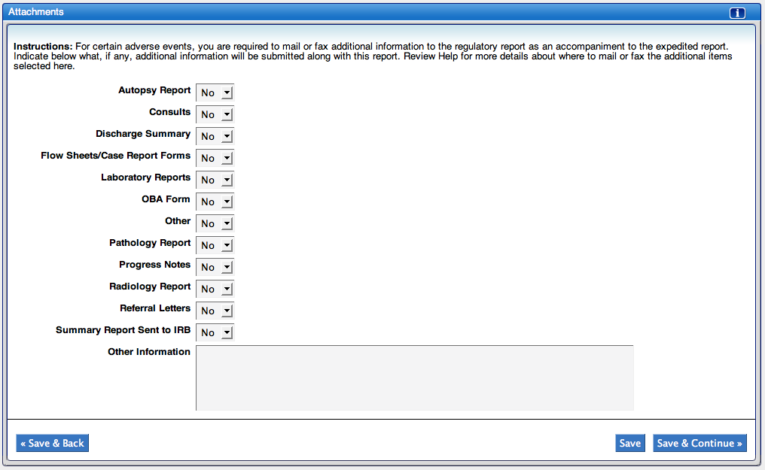

Submit
The submit page shows all reports that are associated with the AE. If the report has all the necessary information, it will have submit/withdraw options. If it is missing information, it will show what information is missing in the Ready to submit? field. Until all the issues are resolved, you will not be able to submit the report. The § icon on the Section tabs will help you located what sections are missing information.
- If there are issues with the report, click Withdraw; once a report is withdrawn, changes have to be made to the report to be able to submit it
- If a report is missing information, review the Ready to submit? field for information about what is missing and return to the section(s) that are missing information (look for the § icon on the Section tabs)
- If you are not ready to submit the report, click Save & Back or Go to Manage Reports
or
If all information is provided and you are ready to submit the report, click Submit
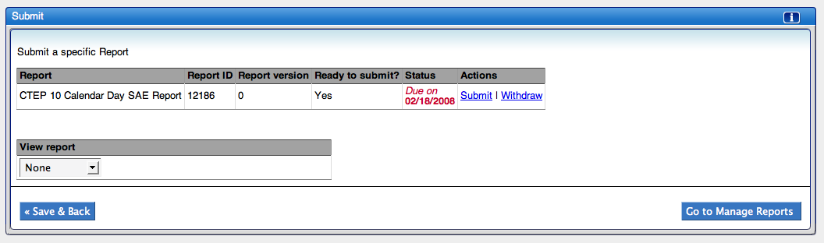

Submitter
The submitter page verifies you have physician sign-off and collects the submitter’s information. To complete the page:
- Select {Yes or No} for physician sign-off
- If the submitter is either the reporter or the physician, select Submitter same as reporter or Submitter same as physician; if not, continue to step 3
Note: this will copy the information from the Reporter details section into the physician details section
- Enter the submitter’s {First Name}
- Enter the submitter’s {Middle Name}, if desired
- Enter the submitter’s {Last Name}
- Enter the submitter’s {E-mail address}
- Enter the submitter’s {Phone number}, if desired
- Enter the submitter’s {Fax number}, if desired
- Click Save or Save & Continue
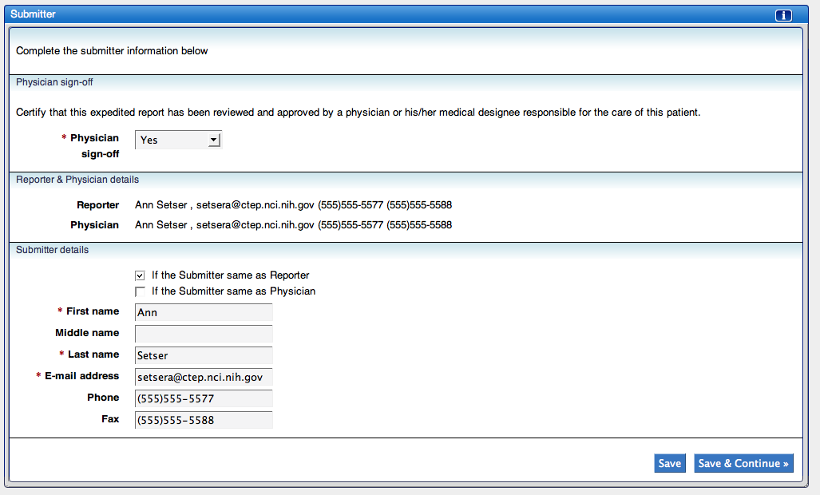

Submit Report
- Verify where the report is being sent. If the report needs to go to more locations than appear under Email/URL, enter the {email addresses} in the CC field
- Click Save to submit the report
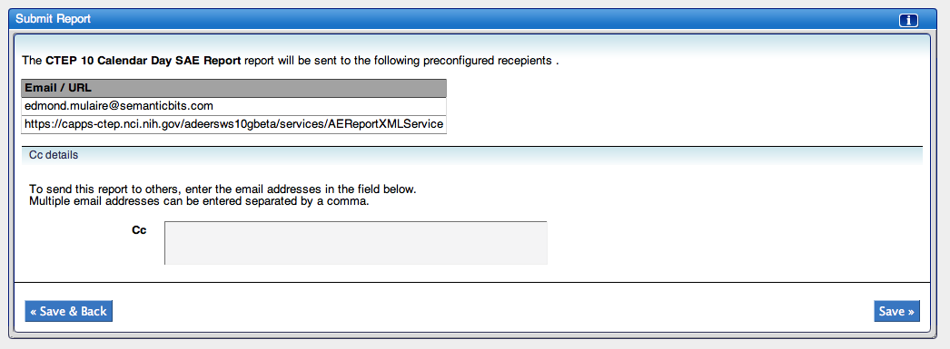

Documenting Routine AEs
Some AEs may not require expedited reports because they are not considered serious, and may or may not be expected. This type of AE is documented in caAERS through the Document routine AEs task of the Adverse Events Module.
Documenting a routine AE is done in three or four steps, depending on the vocabulary used. These steps are:
- Begin
- Categories (only if the CTC vocabulary list is used)
- Adverse Events
- Save

Begin
To start documenting a routine AE, you must select the subject and the study. To do this:
- Begin typing the subject’s {name} and select {the subject’s name} from the list when it appears
- Begin typing the {study} and select {the study} from the list when it appears
- Click Continue
Note: You can select the study first – the order does not matter

Categories
If the study selected uses the CTC terminology, you will need to select the categories the AE(s) may fall in. To select the categories:
- Enter the {date (mm/dd/yyyy)} the period of observation started
- Enter the {date (mm/dd/yyyy)} the period of observation ended
- Select the {treatment assignment code} from the dropdown list
- Select {the CTC categories} that are associated with the AE for the observation period
Note: You may select multiple categories
- Click Continue
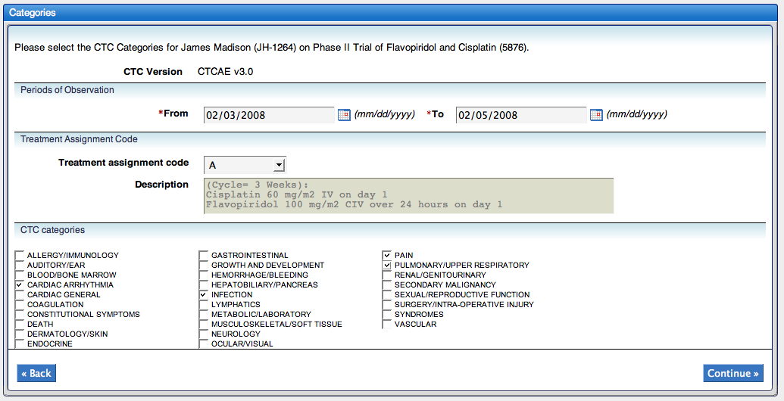

Adverse Events
Routine AE details need to be added to the report. This is done differently depending on the vocabulary used.

Adding an AE – CTC vocabulary:
- Select a {CTC Category}
- Select the {CTC Term} associated to the AE
Note: You can select multiple CTC Terms at the same time by holding down the CTRL key while clicking on the term
- Click Add. Repeat steps 2-3 to add all AE before adding the details for the AE (steps 4-7)
or
Continue to step 4

- Select {the level of severity} of the Adverse Event (grade)
- Select {how likely the AE is related to the agent}; is this adverse event possibly caused or related to any intervention in the study
- Did this AE result in hospitalization or prolongation of hospitalization? Select the appropriate answer
- Was this AE an expected result? Select {Yes or No}
- If you didn’t add all AEs initially, repeat steps 1-7
or
if you did add all AEs initially, repeat steps 4-7 to enter the details
or
Click Continue
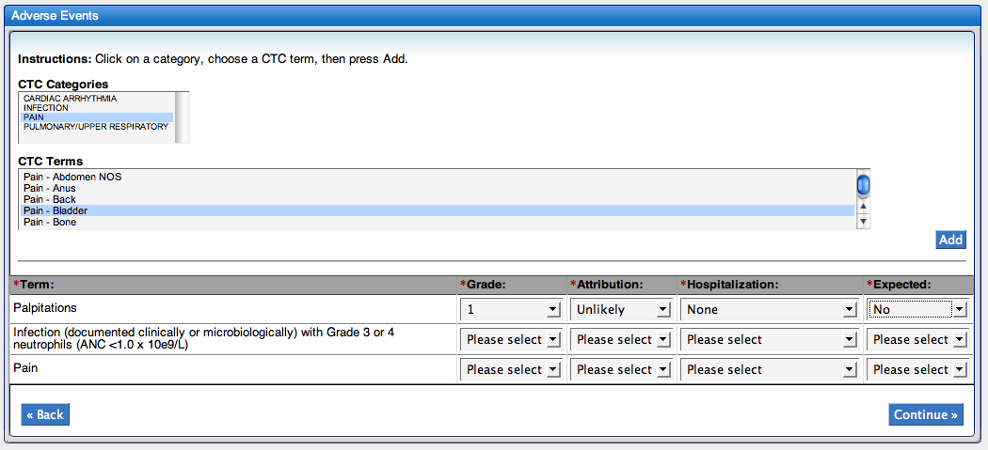

Adding an AE – MedDRA vocabulary:
- Enter the {date (mm/dd/yyyy)} the period of observation started
- Enter the {date (mm/dd/yyyy)} the period of observation ended
- Select the {treatment assignment code} from the dropdown list
- Start typing the {MeDRA term} and select the {MeDRA term} from the list when it appears. Repeat steps 3-4 to add all AE before adding the details for the AE (steps 5-8)
or
Continue to step 5
- Select {the level of severity} of the Adverse Event (grade)
- Select {how likely the AE is related to the agent}; is this adverse event possibly caused or related to any intervention in the study
- Did this AE result in hospitalization or prolongation of hospitalization? Select the appropriate answer
- Was this AE an expected result? Select {Yes or No}
- If you didn’t add all AEs initially, repeat steps 1-8
or
if you did add all AEs initially, repeat steps 5-8 to enter the details
or
Click Continue
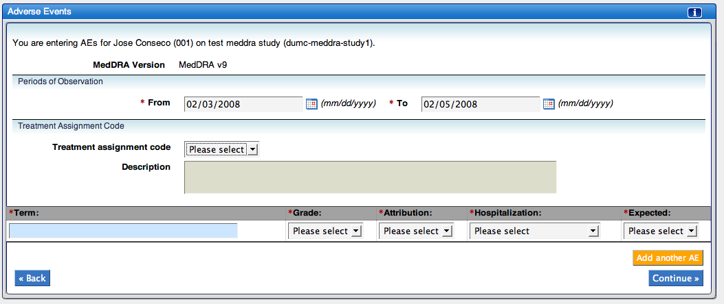

Save
The last section of the process summarizes the AEs you have entered. To create the report:
- Click Save
- The Manage Reports task will come up and show the subject’s reports for that study
Note: Based on the study, caAERS may determine the AE is serious enough to require an expedited report. If this is the case, it will take you to the expedited report task, and the AE will be listed under both Adverse Events and Routine Events.
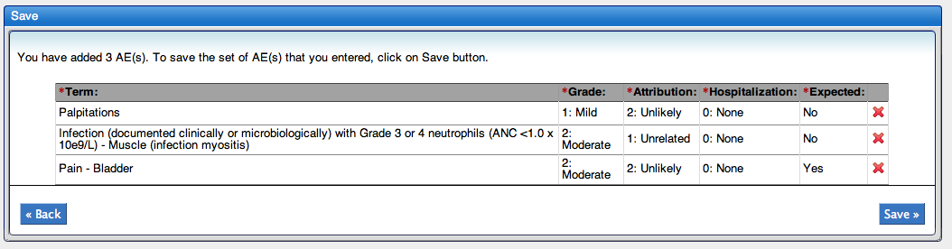

Managing Reports
The Manage reports task of the Adverse Event module is a centralized reporting area where you can view a list of all reports, both expedited and routine, for a given user-study combination. You can also see if the report is incomplete, select the report to view the full details, generate a pdf or xml version of the report, generate a MedWatch pdf, or send notification to the patient study calendar. To manage a subject’s reports for a specific study:
- Begin typing the subject’s {name} and select {the subject’s name} from the list when it appears
- Begin typing the {study} and select {the study} from the list when it appears
- Click Continue
Note: You can select the study first – the order does not matter
- Here you can view all the reports. The first table lists all Expedited reports. You can click Create next to Expedited Reports to create a new expedited report. The second table lists all routine reports. You can click Create next to Routine AEs to create a new routine AE report.
- To tell if a report is incomplete, look in the left-hand column. If there is an icon there, , it means the data is incomplete. If you click on the icon, it will change and provide more detailed information.
- To view more details on the report, click on {the report} from the Term column. This will open the report in either the expedited report task or routine AEs task, depending on the type of report.
- The Actions column provides a list of actions that can be taken for each report.
- If you’ve installed the Patient Study Calendar, click notify PSC to notify the calendar of the AE/report
- To create an AdEERS PDF of the report, select AdEERS PDF
- To create an XML version of the report, select caAERS XML
Note: There may be additional actions based on the report selected.
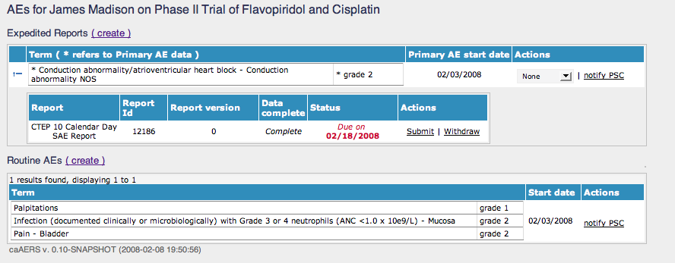

Advanced Search
This chapter provides an overview of the Advanced Search module. Topics in this chapter include:

- Overview
- Study Search
- Subject Search
- AE search
- Expedited Report search
- Routine AE search

Overview
The Advanced Search module enables a user to quickly search and locate different information in caAERS. Different users will have access to different search tasks, based on the roles they were assigned.
Each of the search tasks work the same way as the searches in the other modules. The following sections provide step-by-step instructions on using these search options.

Study Search
The study search allows the user to locate a particular study, searching by study or subject information. To search for a study:
- Click Study search from the Advanced Search module
- Enter {search criteria} in any of the fields of the Study Criteria box, the Subject Criteria box, or both and then click Search
Note: You can also just click Search to list all Studies
- The Studies available will be listed. You can further refine the search by typing something in the Primary ID, Short Title, Sponsor, Phase, and Status filter fields and then clicking Filter
- To view the study and/or make changes to it, click on {the study’s Primary ID}

Subject Search
The subject search allows the user to locate a particular subject, searching by study or subject information. To search for a subject:
- Click Subject search from the Advanced Search module
- Enter {search criteria} in any of the fields of the Study Criteria box, the Subject Criteria box, or both and then click Search
Note: You can also just click Search to list all Subjects
- The Subjects available will be listed. You can further refine the search by typing something in the Primary ID, First Name, Last Name, Gender, Race, Ethnicity, and Associated Study ID(s) filter fields and then clicking Filter
- From here, you can view the subject by clicking on {the subject’s Primary ID} or view the associated study and/or make changes to it by clicking on {the associated study’s ID}

AE Search
The AE search allows the user to locate an AE, searching by AE, study, or subject information. To search for an AE:
- Click AE search from the Advanced Search module
- Enter {search criteria} in any of the fields of the AE Criteria box, Study Criteria box, the Subject Criteria box, or all three and then click Search
Note: You can also just click Search to list all Subjects
- The AEs available will be listed. You can further refine the search by typing something in the Study ID, Sponsor, AE Type, CTC Category, CTC Term, Grade, MedDRA Code, and Start Date filter fields and then clicking Filter

Expedited Report Search
The Expedited Report search allows the user to locate a report searching by expedited report, study, or subject information. To search for an expedited report:
- Click Expedited Report search from the Advanced Search module
- Enter {search criteria} in any of the fields of the Expedited Report Criteria box, Study Criteria box, the Subject Criteria box, or all three and then click Search
Note: You can also just click Search to list all Subjects
- The expedited reports available will be listed. You can further refine the search by typing something in the Primary CTC term, Grade, Attribution, Start Date, Study ID, and Subject ID filter fields and then clicking Filter
- From here, you can view the associated study or subject and/or make changes to it by clicking on {the study’s ID} or the {the subject ID}

Routine AE Search
The Routine AE search allows the user to locate a Routine AE report, searching by Routine report, study, or subject information. To search for a routine AE report:
- Click Routine AE search from the Advanced Search module
- Enter {search criteria} in any of the fields of the Routine Report Criteria box, Study Criteria box, the Subject Criteria box, or all three and then click Search
Note: You can also just click Search to list all Subjects
- The Routine AE reports available will be listed. You can further refine the search by typing something in the Primary CTC term, Grade, Attribution, Observation Dates, Study ID, and Subject ID filter fields and then clicking Filter
- From here, you can view the associated study or subject and/or make changes to it by clicking on {the study’s ID} or the {the subject ID}

Error Messages/Indicators and Problem Resolutions
This chapter provides information about error messages and problem resolution. Topics in this chapter include:
- Error messages/Issues
- Support

Error Messages
caAERS has been setup to provide descriptive messages whenever it encounters a problem.
- submission errors
- import issues
- activity issues
- system errors

Submission Errors

I get an error when I try to save or continue
As you go through the modules and try to save changes, you may forget to add information and receive an error. The error will state what information is missing.

I get an error when I try to go back to a previous section
caAERS is setup to check a page for all required information before moving to the next section. If you want to go to a previous section, you may receive an error on the previous page about missing information. This is just the information it expected to be entered before you went back. At other times, it may not allow you to go back until you fill out the required fields (the information will be saved when you come back to the page).

Activity Issues

I was taken back to the log on page
caAERS automatically logs out inactive accounts. If you’ve been inactive and then you try to access a module or click on a button, it’ll have you log back in before accessing the module. You will lose any unsaved information.
caAERS will automatically log you out after approximately 30 minutes of idle time.

I had to start over while entering information
If you went idle while entering information across multiple pages, such as an adverse event, you may lose your information because the system automatically logged you out. To verify the information is lost, you can use the advanced search feature to search for the partially created report, study, etc.

System Errors
You may run into a system error. If this happens, you should contact the support team. They may request the detailed error information, so either save the website or copy the information.

Support
To get support when you have issues, please check the caAERS Project site, http://gforge.nci.nih.gov/projects/caaersappdev/ or contact support at edmond.mulaire@semanticbits.com.
- References

Scientific Publications
- Cancer Therapy Evaluation Program, “Common Terminology Criteria for Adverse Events, Version 3.0", ctep.cancer.gov/forms/CTCAEv3.pdf
- Cancer Therapy Evaluation Program, “Adverse Event Expedited Reporting System (AdEERS)", ctep.cancer.gov/forms/CTCAEv3.pdf
- Cancer Therapy Evaluation Program, “CTEP, NCI Guidelines: Adverse Event Reporting Requirements", http://ctep.cancer.gov/reporting/newadverse_2006.pdf
- Division of Cancer Prevention, “DCP Serious Adverse Event Reporting Procedures and Guidelines, http://dcp.cancer.gov/clinicaltrials/management/consortia/step-3/adverse
- Division of Cancer Prevention, “DCP Serious Adverse Event Reporting Form, http://dcp.cancer.gov/Files/clinical-trials/sae_guidelines.doc
- FDA, “The FDA Safety Information and Adverse Event Program”, http://gforge.nci.nih.gov/projects/ccts/

caBIG Material
- caBIG: http://cabig.nci.nih.gov/
- caBIG Compatibility Guidelines: http://cabig.nci.nih.gov/guidelines_documentation
- caBIG Clinical Trial Suite Project Site: http://gforge.nci.nih.gov/projects/ccts/

caGrid Material
- caGrid: http://www.cagrid.org/mwiki/index.php?title=CaGrid

caCORE Material
- caCORE: http://ncicb.nci.nih.gov/core
- caBIO: http://ncicb.nci.nih.gov/core/caBIO
- caDSR: http://ncicb.nci.nih.gov/core/caDSR
- EVS: http://ncicb.nci.nih.gov/core/EVS
- CSM: http://ncicb.nci.nih.gov/core/CSM
- Glossary
The following is a list of terms and their definitions that you may find useful as you work with caAERS.
Term | Definition
AdEERS | Adverse Event Expedited Reporting System
AE | Adverse Event
API | Application Programming Interface
caArray | cancer Array Informatics
caBIG | cancer Biomedical Informatics Grid
caBIO | Cancer Bioinformatics Infrastructure Objects
caCORE | cancer Common Ontologic Representation Environment
caDSR | Cancer Data Standards Repository
caMOD | Cancer Models Database
cardinality | Cardinality describes the minimum and maximum number of associated objects within a set
CRA | Clinical Research Associate
CTC | Common Toxicity Criteria
CTMS | Clinical Trials Management System
CSM | Common Security Module
CTEP | Cancer Therapy Evaluation Program
CUI | Concept Unique Identifier
CVS | Concurrent Versions System
DCP | Division of Cancer Prevention
EVS | Enterprise Vocabulary Services
FDA | Food and Drug Administration
GAI | CGAP Genetic Annotation Initiative
HTTP | Hypertext Transfer Protocol
JDBC | Java Database Connectivity
JET | Java Emitter Templates
JMI | Java Metadata Interface
JSP | JavaServer Pages
LLT | Lowest Level Term
MedDRA | Medical Dictionary for Regulatory Activities
MedWatch | The FDA Safety Information and Adverse Event Reporting Program
metadata | Definitional data that provides information about or documentation of other data.
multiplicity | Multiplicity of an association end indicates the number of objects of the class on that end may be associated with a single object of the class on the other end
NCI | National Cancer Institute
NCICB | National Cancer Institute Center for Bioinformatics
OIL | Ontology Inference Layer
OilEd | Ontology editor allowing you to build ontologies using DAML+OIL
PT | Preferred Term
SQL | Structured Query Language
SSC | Special Search Categories
UML | Unified Modeling Language
UMLS | Unified Medical Language System
UPT | User Provisioning Tool
URL | Uniform Resource Locators
XML | Extensible Markup Language

Index

Add
expedited report, 33
routine AE, 51
Study, 15
subject, 25
Adverse Events
expedited report, 33
managing reports, 54
Overview, 33
routine AE, 51
Errors, 61
Glossary, 65
Help, 7
Navigating in caAERS, 6
Password
resetting, 4
References
caBIG material, 63
caBIG materials, 63
caCORE material, 63
scientific publications, 63
Search
advance, 57
AE, 54, 58
expedited report, 54, 58
general, 8
routine AE, 58
Study, 23, 57
subject, 30, 57
Study
add, 15
edit, 24
overview, 15
search, 23
Subject
assigning to a study, 27
creating, 25, 31
editing, 31
overview, 25
search, 30
Support
contacts, iv
listserv, iv
relevant documents, 2
System Requirements, 3
Text conventions, Supplement, 2
Troubleshooting. See Errors
User Role
AE coordinator, 11
investigator, 11
Overview, 11
site coordinator, 11
Study coordinator, 11
subject, 11
subject coordinator, 11

